Smart House Weather Dashboard Documentation

Documentation for the Smart House Weather Dashboard EULA and User Manual

Author: S275931

Smart House Weather Dashboard Documentation

Table of Contents

Introduction 1

End User License Agreement 2

Terms of Use 2

System Requirements 3

Docker Deployment (Windows): 3

Docker Deployment (macOS): 4

Docker Deployment (Linux): 5

Render.com deployment (online): 5

Installation 5

Setup Render.com Deployment 7

Installation and Setup using Docker Deployment 7

Using the Smart House Weather Dashboard 12

Viewing the home page dashboard 12

Viewing the Digitech Smart House Temperature 13

Viewing the Digitech Smart House Humidity 17

Viewing the Weather Dashboard 20

Viewing the Weather Maps 33

References 39

# Introduction

The Smart House Weather Dashboard is a Python-based web application that obtains live indoor and outdoor temperature and humidity data and live weather data from sensors and a weather station at the Digitech Smart House that is used by the University of Suffolk and is located at Adastral Park in Martlesham, Ipswich, Suffolk, United Kingdom. The Smart House Weather dashboard also obtains additional weather data, pollen data and weather forecasts (hourly and daily) from third party weather APIs. The APIs providing this data include WeatherLink, OpenWeather, Weather API and Ambee. This application also obtains historical hourly, daily, and monthly temperature and humidity data through Kaggle and presents this data as user friendly graphs. Finally, this application presents the temperature and humidity sensor data, weather data and historic data on a series of user-friendly dashboards and graphs that is hosted on an online web application that is publicly accessible. The Smart House Weather Dashboard can also be installed and deployed locally using Docker.

# End User License Agreement

IMPORTANT – YOU MUST AGREE TO THE SMART HOUSE WEATHER DASHBOARD GNU AGPLv3 LICENSE BEFORE YOU CAN USE THIS PRODUCT IN ANY WAY.

The full license agreement is available in a separate document. The Smart House Weather Dashboard is open source with the copyleft GNU Affero General Public License.

You must comply with the following permissions, conditions and limitations when using, managing, downloading, installing, setting up, distributing, deploying, or modifying the Smart House Weather Dashboard as stated in the table below in accordance with the open-source GNU Affero General Public License Agreement. Failure to comply can result in legal action under U.K. law, international law, and local laws of your country where you are using this software.

The GNU Affero General Public License Agreement is available here: <https://www.gnu.org/licenses/agpl-3.0.en.html>

Alternative links to license agreement: <https://github.com/AlexanderJohnRobertson/Dissertation-Smart-Home-Weather-Dashboard/wiki/License>

|  |  |  |
| --- | --- | --- |
| Permissions | Conditions | Limitations |
| Commercial Use is Authorised | You Must Disclose the Original Source | Liability – We cannot be held liable for any damage or data loss caused by modifications. |
| Distribution is Authorised | You Must Include License and Copyright Notice | Warranty – Modified code is not covered by warranty. |
| Modification is Authorised | Network use is Distribution |  |
| Patent Use is Authorised | You Must Use the Same License |  |
| Private Use is Authorised | You Must State Changes (Choose an open source license, 2007) |  |

# Terms of Use

IMPORTANT – YOU MUST AGREE TO THE TERMS OF USE BEFORE YOU CAN USE THE SMART HOUSE WEATHER DASHBOARD IN ANY WAY.

1. You must accept the license agreement (see above).
2. You must comply with the license agreement and must not violate it or else you could face legal action under U.K. law, international law, and local laws in the country you are using this software.
3. You must not violate the terms of use or else you could face legal action under U.K. law, international law, and local laws in the country you are using this software.
4. You must not use the Smart House Weather Dashboard for illegal purposes or to support criminal activity.
5. You must not modify and redistribute the Smart House Weather Dashboard by inserting malicious code in any language into the source code to turn it into malware. This includes but not limited to:
   1. Viruses
   2. Trojans
   3. Worms
   4. Adware and Malvertising
   5. Spyware
   6. Ransomware
   7. Rootkits
   8. Browser Hijackers
   9. Potentially Unwanted Programs
   10. Cryptominers
   11. Keyloggers
   12. Password Stealers
   13. Hack tools.
   14. Browser Hijackers
   15. Links to third party malware websites, scam websites and spam websites
   16. Spambots, Bots and Botnets
   17. Exploits
   18. Backdoors
   19. Logic Bombs
   20. (Distributed) Denial of Service Attack
   21. Fileless Malware
6. You must comply the relevant laws and regulations of the country(s) you are using the Smart House Weather Dashboard in and not break them. Failure to comply can result in civil and criminal prosecution. These include:
   1. Data Protection Act and General Data Protection Regulations
   2. Computer Misuse Act
   3. Communications Act and Malicious Communications Act
   4. Telecommunications Act.
7. You must not use the Smart House Weather Dashboard or modify it in a way to facilitate cybercrimes. This includes but is not limited to:
   1. Malware (see above for examples)
   2. Break the laws listed above.
   3. Hacking
   4. Spying and espionage
   5. Identity Theft
   6. Any type of fraud
   7. Phishing
   8. Spam
   9. Scams
8. You must not redistribute this software with a proprietary license and sell it for money and pretend it is your own or with any other type of license. The license must stay the same.
9. As the software is currently free, you must not sell it for any amount of money.

# System Requirements

## Docker Deployment (Windows):

* Computer must meet the system requirements to run Docker and a compatible web browser.
* 64 Bit Windows 10 Home, Professional, Enterprise or Education 22H2 (build 19045) or later or Windows 11 Home, Professional, Enterprise or Education version 22H2 or later (Docker, Inc., 2024).
* Docker Desktop and compatible web browser installed.
* Windows Subsystem for Linux (WSL) 2 feature enabled with a Linux operating system installed (Available from the Microsoft Store) or Hyper-V and Windows Containers features enabled (Docker, Inc., 2024).
* Professional and Enterprise editions of Windows are required to run Windows containers (Docker, Inc., 2024).
* 64-bit processor (CPU) with Second Level Address Translation (SLAT) (Docker, Inc., 2024) (Extended Page Table (EPT) in Intel processors, Rapid Virtualisation Indexing (RVI) in AMD processors) (Gibb, 2011).
* 4GB system RAM (Docker, Inc., 2024) (More may be required if application is scaled).
* Hardware Virtualisation enabled in computer BIOS (Docker, Inc., 2024).
* Internet connection.
* Tested web browsers include Mozilla Firefox, Microsoft Edge, Google Chrome, and Safari but should run on other web browsers too.
* 416 MB disk space for Smart House Weather Dashboard container.
* 100 GB disk space for Docker as Docker can take up substantial amounts of disk space (Kinda Code, 2022).
* Mozilla Firefox System Requirements: 1GHz processor (CPU), 2GB RAM, 500 MB disk space (Mozilla, 2024).
* Microsoft Edge is bundled with Windows 10 and 11 (Microsoft, 2024).
* Google Chrome System Requirements: Windows 10 or 11, Intel Pentium 4 processor (CPU) or AMD equivalent (Google, 2024).

## Docker Deployment (macOS):

* Docker is compatible with most recent versions of macOS (Docker, Inc., 2024).
* Docker is compatible with Apple Silicon chips (CPUs) such as M1, M1 Pro, M1 Max, M1 Ultra, M2, M2 Pro, M2 Max, M2 Ultra, M3, M3 Pro, M3 Max, M4, M4 Pro, M4 Max and future Apple Silicon processors (Docker, Inc., 2024).
* Docker is compatible with most recent Intel CPUs in Macs with Intel chips (Docker, Inc., 2024).
* 4 GB RAM (Docker, Inc., 2024) (more RAM may be required if scaled)
* 100 GB disk space for Docker as Docker can take up substantial amounts of disk space (Kinda Code, 2022).
* 416 MB disk space for Smart House Weather Dashboard container.
* Internet Connection.
* Tested web browsers include Mozilla Firefox, Microsoft Edge, Google Chrome, and Safari but should run on other web browsers too.
* Mozilla Firefox System Requirements: macOS 10.15 or later (Catalina), Intel or Apple Silicon processor (CPU), 512 MB RAM, 200 MB disk space (Mozilla, 2024).
* Google Chrome System Requirements: Big Sur and up (Google, 2024).
* Safari System Requirements: Safari is bundled with macOS (Apple, 2024).

## Docker Deployment (Linux):

* Supported Linux Distributions: Ubuntu, Debian, Fedora, Red Hat Enterprise Linux (Docker, Inc., 2024).
* 64-bit kernel and processor (CPU) for virtualisation (Docker, Inc., 2024).
* KVM virtualization support (Docker, Inc., 2024).
* QEMU 5.2 or later (Docker, Inc., 2024).
* systemd init system (Docker, Inc., 2024).
* Gnome, KDE, or MATE Desktop environment (Docker, Inc., 2024).
* 4 GB RAM (Docker, Inc., 2024) (more RAM may be required if application is scaled).
* Configuring ID mapping in user namespaces enabled (Docker, Inc., 2024).
* Initialize pass recommended for credentials management (Docker, Inc., 2024).
* 100 GB disk space for Docker as Docker can take up substantial amounts of disk space (Kinda Code, 2022).
* 416 MB disk space for Smart House Weather Dashboard container
* Internet Connection.
* Tested web browsers include Mozilla Firefox, Microsoft Edge, Google Chrome, and Safari but should run on other web browsers too.
* Mozilla Firefox System Requirements: Following libraries and packages must be installed: glibc 2.17 or higher, GTK+ 3.14 or higher, libglib 2.42 or higher, libstdc++ 4.8.1 or higher, X.Org 1.0 or higher (1.7 or higher is recommended), DBus 1.0 or higher, NetworkManager 0.7 or higher, PulseAudio. Mozilla Firefox is bundled with some Linux distributions (Mozilla, 2024).
* Google Chrome System Requirements: 64-bit Ubuntu 18.04+, Debian 10+, openSUSE 15.2+, or Fedora Linux 32+, SSE3 capable Intel Pentium 4 or later processor (CPU) or AMD equivalent (Google, 2024).

## Render.com deployment (online):

* Any device with compatible browser, operating system, and internet connection.
* Examples of devices include workstations, desktop and laptop computers running Windows, Linux, macOS or ChromeOS, Smartphones running Android and iOS, Tablets and iPads running Android, iOS and iPadOS, Macs running macOS, Chromebooks running ChromeOS, Raspberry Pi etc.
* Tested browsers include Mozilla Firefox, Microsoft Edge, Safari, and Google Chrome. The Smart House Weather Dashboard should be accessible on other browsers too.

# Installation

This section provides Installation instructions for the Smart House Weather Dashboard.

Before installing the Smart House Weather Dashboard, the prerequisite software must be installed first:

* For Docker installation and setup instructions, visit the official Docker website:
  + Install Docker on Windows: <https://docs.docker.com/desktop/install/windows-install/>
  + Install Docker on macOS: <https://docs.docker.com/desktop/install/mac-install/>
  + Install Docker on Linux: <https://docs.docker.com/desktop/install/linux-install/> , <https://docs.docker.com/desktop/install/debian/> , <https://docs.docker.com/desktop/install/fedora/> , <https://docs.docker.com/desktop/install/ubuntu/> , <https://docs.docker.com/desktop/install/archlinux/> .
  + Full Docker Documentation: <https://docs.docker.com/manuals/>
  + Download Docker: <https://www.docker.com/products/docker-desktop/>
* For Render.com instructions, manuals and documentation visit the Render.com official website:
  + Documentation: [Docs + Quickstarts | Render Docs](https://docs.render.com/)
  + Render.com: <https://render.com/>
* For Mozilla Firefox Download and documentation, visit the official Mozilla Firefox website:
  + Documentation: <https://developer.mozilla.org/en-US/docs/Mozilla/Firefox> and <https://support.mozilla.org/en-US/products/firefox/get-started>
  + Download: <https://www.mozilla.org/en-GB/firefox/new/>
* For Google Chrome download and documentation, visit the official Google Chrome website:
  + Documentation: <https://developer.chrome.com/docs/>
  + Help Manual: <https://support.google.com/chrome/?hl=en#topic=7439538>
  + Download: <https://www.google.co.uk/chrome/>
* For Microsoft Edge Documentation and download, visit the Microsoft Edge official webpage:
  + Documentation: <https://learn.microsoft.com/en-us/microsoft-edge/>
  + Help: <https://support.microsoft.com/en-us/microsoft-edge>
  + Download: <https://www.microsoft.com/en-us/edge/download?form=MA13FJ>
* For Safari Download and Documentation, visit the official Safari Website:
  + Documentation: <https://developer.apple.com/documentation/safari-release-notes>
  + Support: <https://support.apple.com/safari>
  + Download: <https://support.apple.com/downloads/safari>
* For the Windows Subsystem for Linux documentation, visit the WSL official website:
  + Documentation: <https://learn.microsoft.com/en-us/windows/wsl/>
* For the Hyper-V manuals, visit the official Microsoft Website:
  + Windows 10: <https://learn.microsoft.com/en-us/virtualization/hyper-v-on-windows/>
  + Windows 11: <https://techcommunity.microsoft.com/t5/educator-developer-blog/step-by-step-enabling-hyper-v-for-use-on-windows-11/ba-p/3745905>
* For download, manuals, and documentation on Windows, visit the official Microsoft Windows website:
  + Documentation: <https://learn.microsoft.com/en-us/windows/>
  + Windows 11: <https://support.microsoft.com/en-us/windows/meet-windows-11-the-basics-a7519756-6807-41e4-be66-ed3b2c0abe0d>
  + Windows 11 Support: <https://support.microsoft.com/en-us/meetwindows11>
  + Windows 11 Download: <https://www.microsoft.com/en-gb/software-download/windows11/>
  + Windows 10: <https://support.microsoft.com/en-us/microsoft-edge/quick-start-guides-for-windows-10-surface-book-and-microsoft-edge-4e603411-16ad-73f7-0923-5aa3d327bb59>
  + Windows 10 Download: <https://www.microsoft.com/en-gb/software-download/windows10>
* For macOS documentation and manuals, please visit the official Apple macOS website:
  + User Guide: <https://support.apple.com/en-gb/guide/mac-help/welcome/mac>
  + Manuals: <https://support.apple.com/manuals/macos>
  + Download (Requires a Mac): <https://support.apple.com/en-us/102662>
* For Linux documentations and downloads, visit the official pages of the Linux distributions:
  + Linux Kernel Documentation: <https://www.kernel.org/doc/html/latest/>
  + Ubuntu documentation: <https://docs.ubuntu.com/>
  + Ubuntu Download: <https://ubuntu.com/download>
  + Debian Documentation: <https://www.debian.org/doc/>
  + Debian Download: <https://www.debian.org/distrib/>
  + Fedora Documentation: <https://docs.fedoraproject.org/en-US/docs/>
  + Fedora Download: <https://www.fedoraproject.org/en/workstation/download> and <https://docs.fedoraproject.org/en-US/fedora/latest/fedora-downloads-info/>
  + Arch Linux Documentation: <https://wiki.archlinux.org/> and <https://wiki.archlinux.org/title/Installation_guide>
  + Arch Linux Download: <https://archlinux.org/download/>

# Setup Render.com Deployment

To set up the Render.com deployment, you just need a device that connects to the internet and a recent version of a web browser installed.

The Smart House Weather Dashboard is available on Render.com here: <https://dissertation-smart-home-weather-dashboard.onrender.com/> .

__________________________________________________________________________________

# Installation and Setup using Docker Deployment

These are instructions on how to install and set up the Smart House Weather Dashboard as a Docker deployment.

1. Docker MUST be installed prior to installation and setup of the Smart House Weather Dashboard and your computer must meet the system requirements to run Docker. For instructions, refer to the Docker documentation (<https://docs.docker.com/manuals/>) and download Docker here: <https://www.docker.com/products/docker-desktop/> .
2. Go to Docker hub to copy the pull command. For clean installation: <https://hub.docker.com/r/alexjrobertson/smarthouseweatherdashboard> .
3. Copy the following Docker pull command: *docker pull alexjrobertson/smarthouseweatherdashboard* into the computer terminal. When using Docker on Linux, you may be required to type ‘sudo’ before entering the Docker commands or else you may get a ‘permission denied’ or ‘access denied’ error. You may also be prompted to enter your computer password (must be an administrator, root or superuser password) into the Linux terminal. This applies to all Docker commands when using Linux.
4. Enter the following Docker command to run the container: *docker container run -d -p 5000:5000 alexjrobertson/smarthouseweatherdashboard:latest*. The port number in red can be changed to suit the specific need of the host running the Smart House Weather Dashboard. This is especially important if you have multiple containers running or multiple applications using localhost as two applications or containers cannot share the same port.

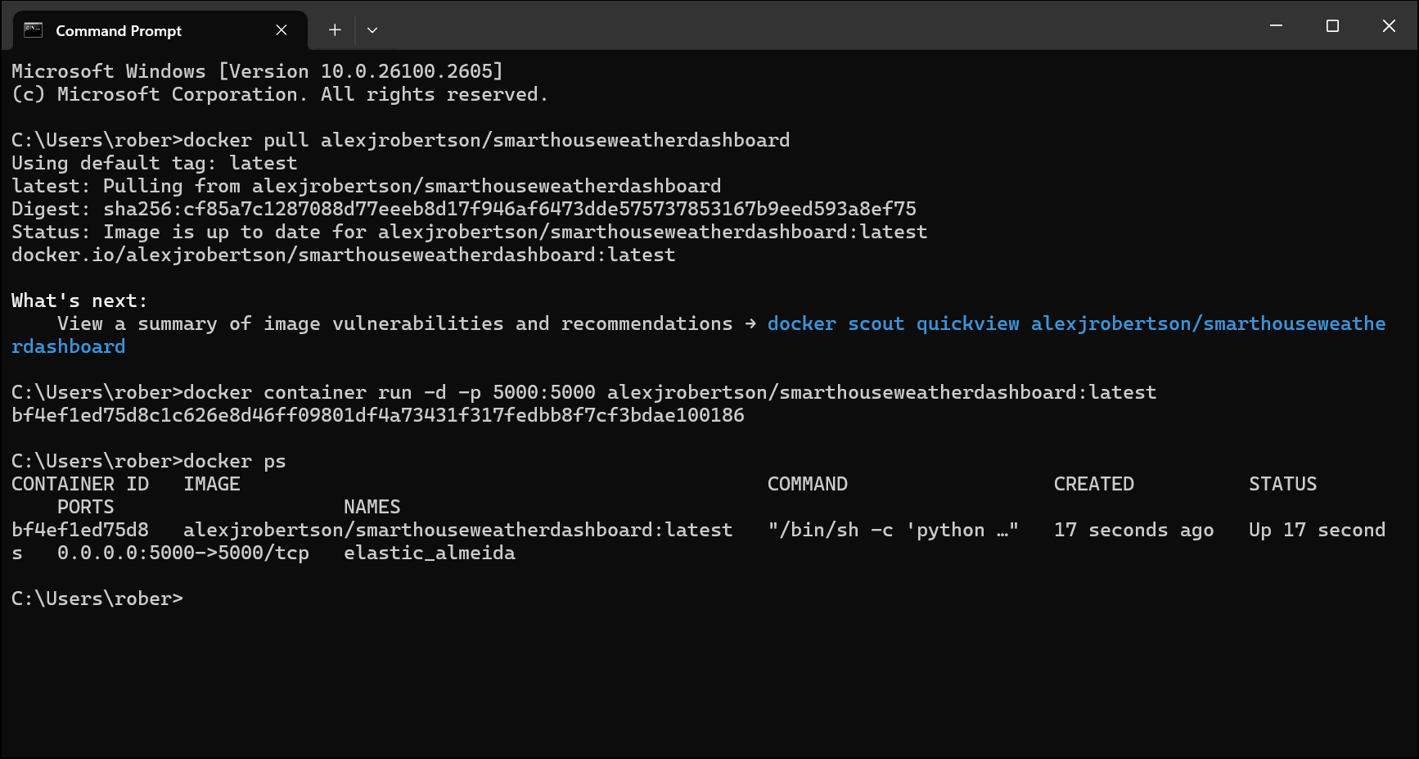

Figure - Example of downloading and running the Smart House Weather Dashboard container using Docker commands in the Command Prompt.

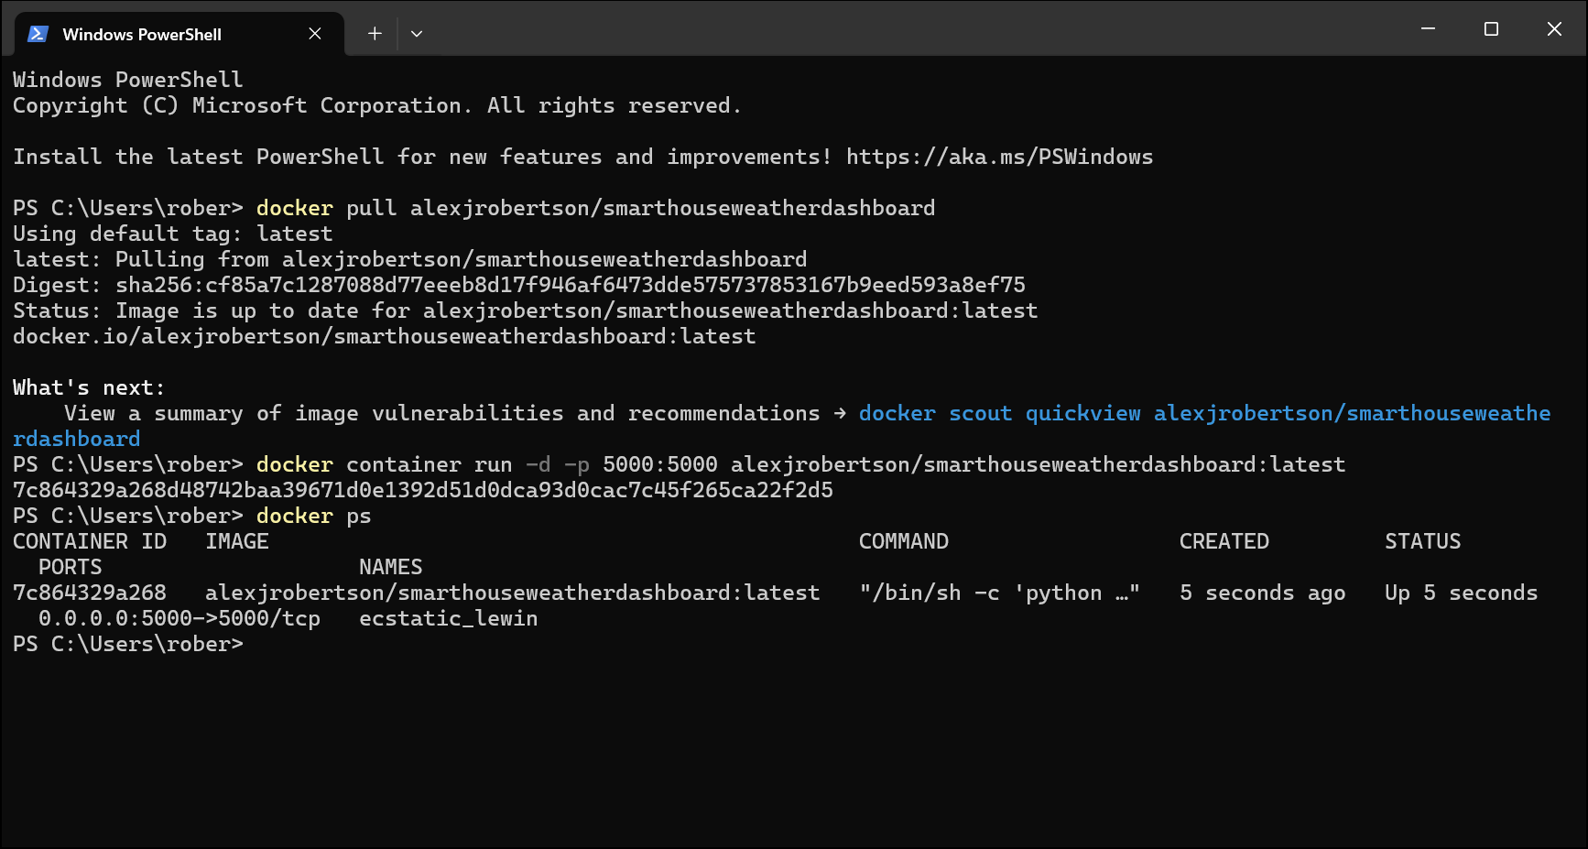

Figure - Example of downloading the Smart House Weather Dashboard image and running the Smart House Weather Dashboard container using Docker commands in the terminal (Windows PowerShell)

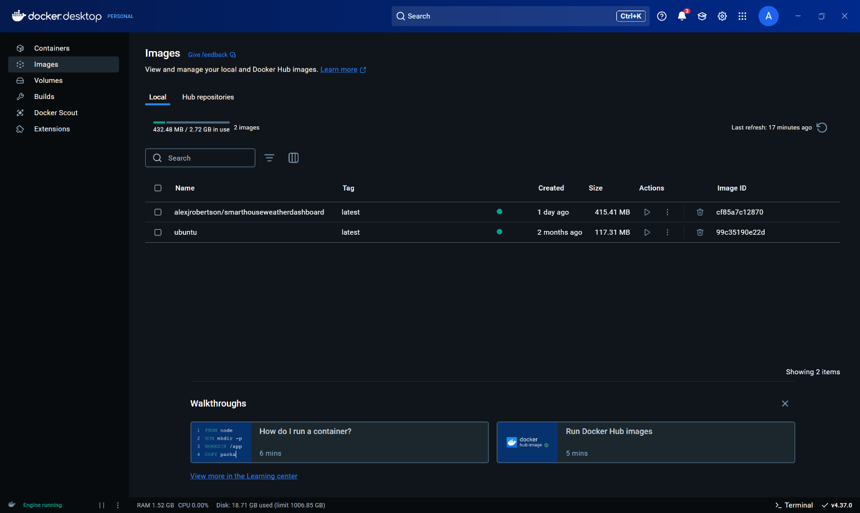

Figure - Smart House Weather Dashboard images visible on Docker Desktop.



Figure - Running Smart House Weather Dashboard containers visible on Docker Desktop.

1. You can also run the Smart House Weather Dashboard containers by clicking the play ▶ buttons beneath the Actions page below the Actions tab on the Images page. Then open Optional Settings in the popup menu that appears and assign a port to the container and then click Run. See the screenshot below for an example.

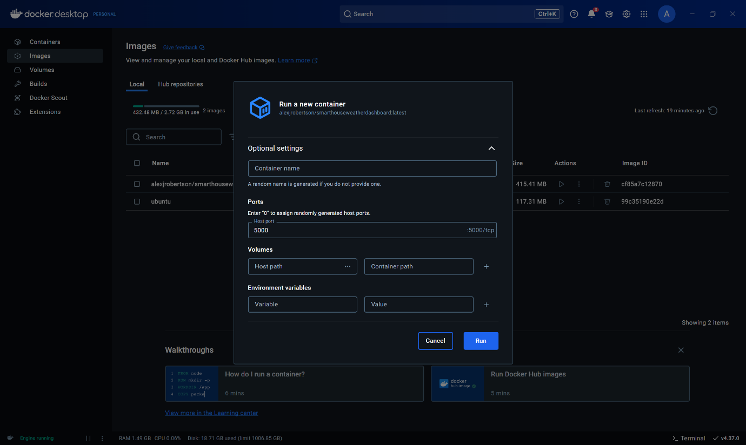

Figure - Running the Taks Management System container from Docker Desktop GUI. Make sure to assign a port number.

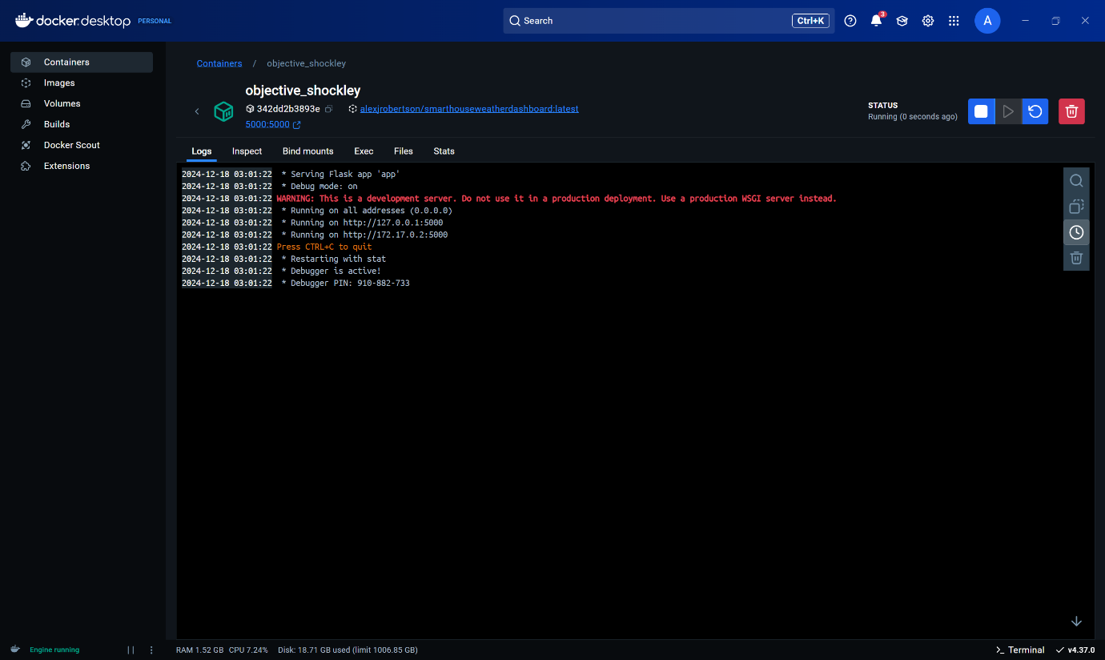

Figure - Docker Desktop after running the Smart House Weather Dashboard container.

1. Type localhost:<port number> e.g. localhost:5000 or localhost:5500 into the web browser address bar and press enter. The port you enter must be the same as the one you entered in the *docker container run* command. The Smart House Weather Dashboard Landing page (Home / index.html) will appear.

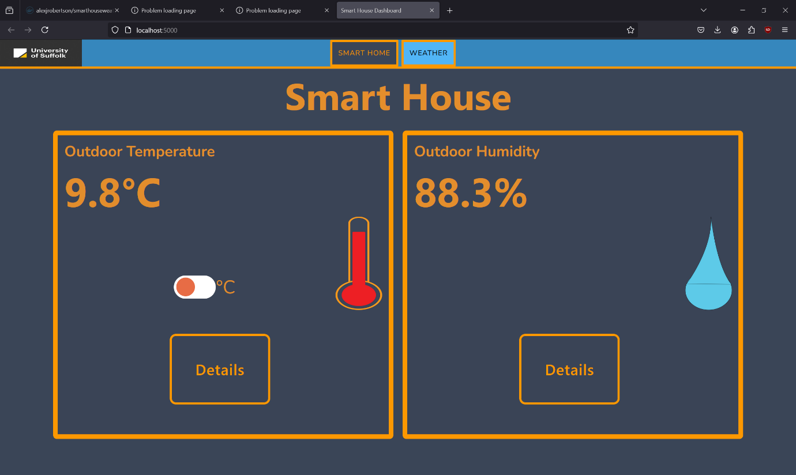

Figure - The Smart House Weather Dashboard landing page is loaded when you enter localhost:<container port number> e.g. localhost:5000 into the address bar in your web browser.

1. To stop the Smart House Weather Dashboard Docker containers, Click the Stop ◼ buttons below the Actions tab on the Containers page on Docker Desktop or type docker *stop <container_id>* where *<container_id>* is the ID number or name of the container. See the two screenshots below for an example.

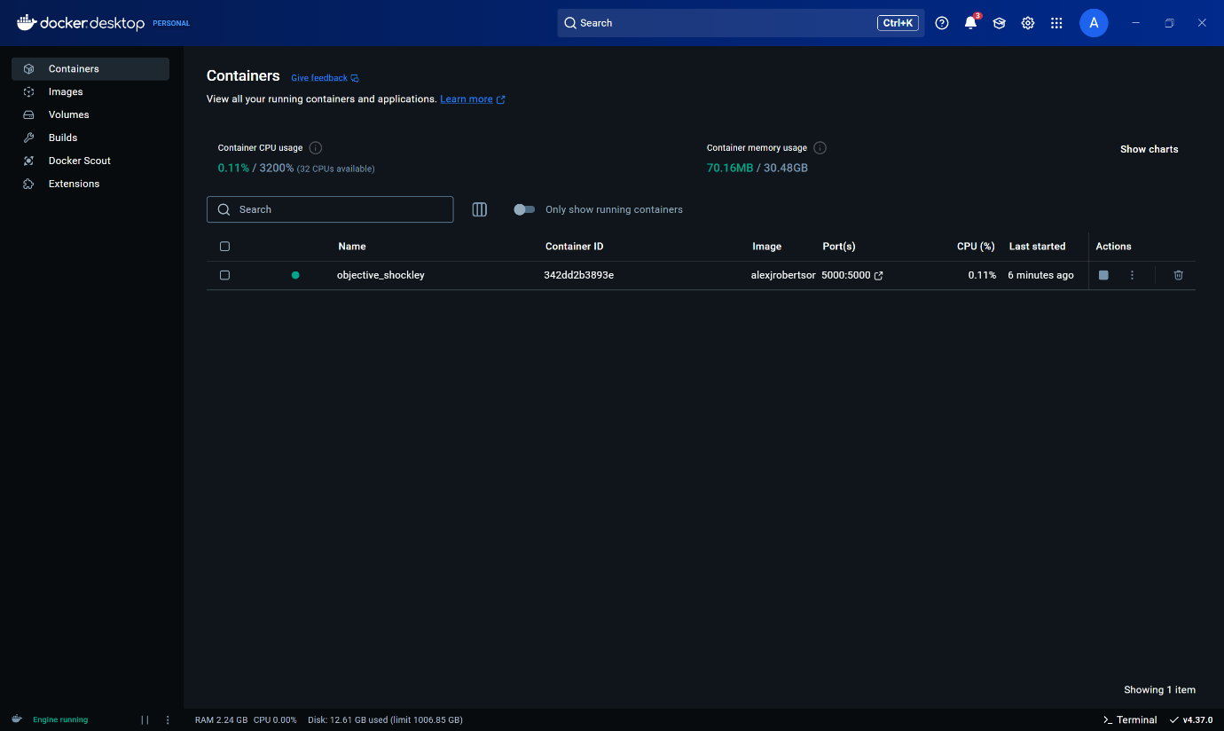

Figure - Stopping Smart House Weather Dashboard containers in Docker Desktop.

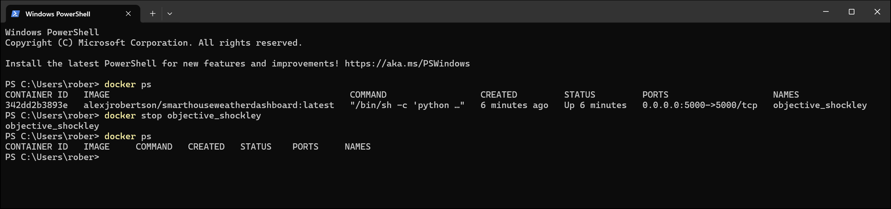

Figure - Using docker stop commands using the Command Prompt / PowerShell / Terminal

# Using the Smart House Weather Dashboard

## Viewing the home page dashboard

1. Go to <https://dissertation-smart-home-weather-dashboard.onrender.com/> or localhost:<port-number> on Docker deployments to view the dashboard landing page.
2. You will be able to view the outdoor temperature and humidity of the Digitech Smart House.

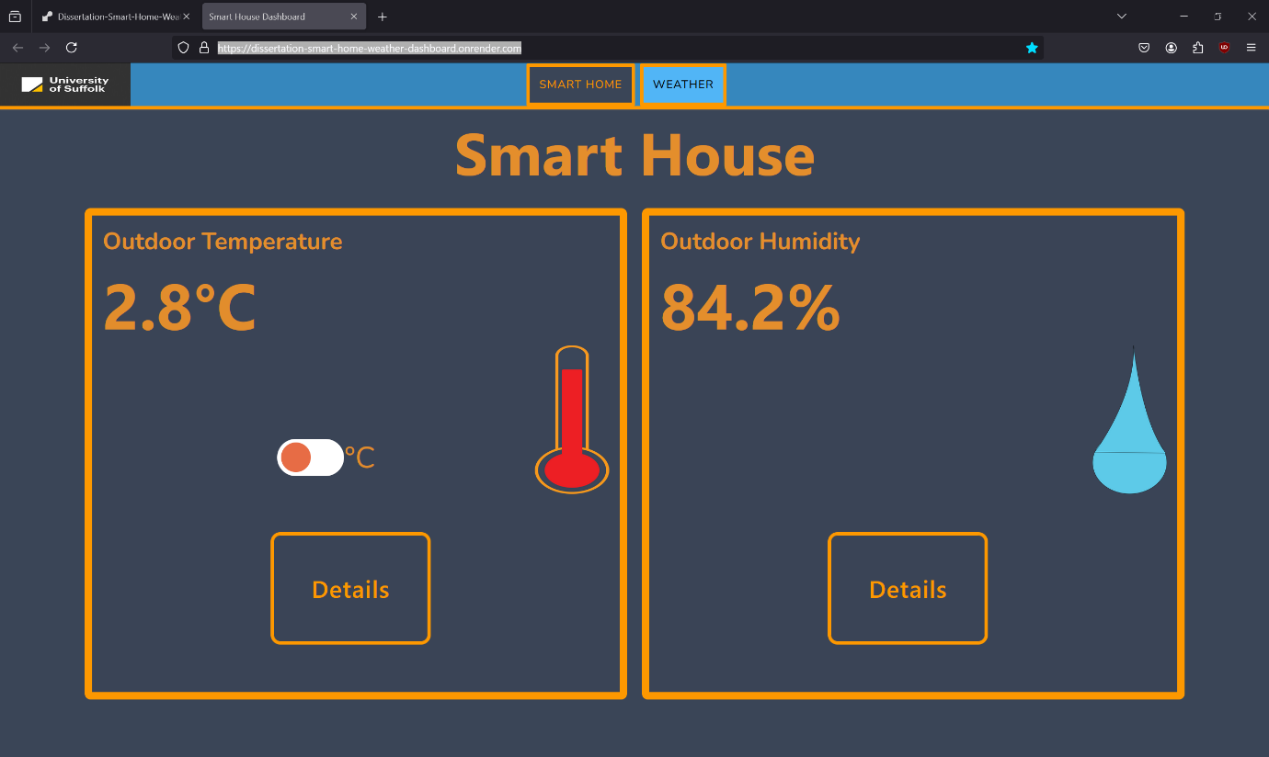

Figure - Smart House Weather Dashboard Landing Page with outdoor temperature and humidity.

1. Change the temperature between Celsius and Fahrenheit using the C/F toggle switch.



Figure - Temperature in Celsius

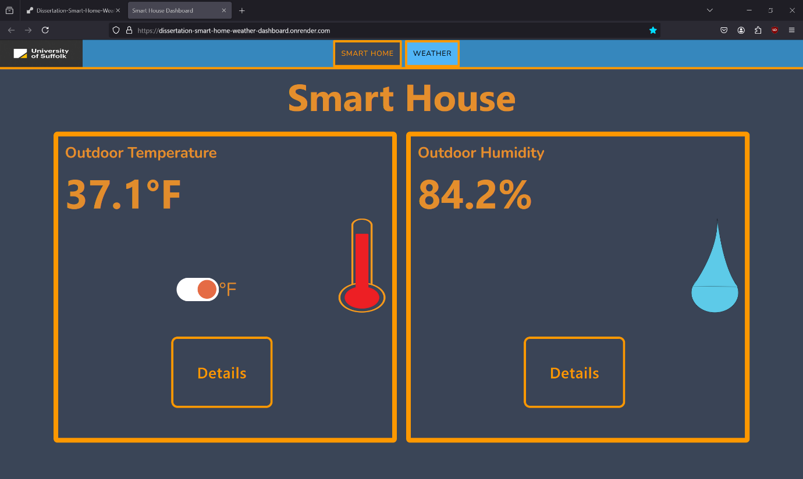

Figure - Temperature in Fahrenheit

## Viewing the Digitech Smart House Temperature

1. Click the “Details” button on the temperature tile.



Figure - Click the Details button on Outdoor Temperature tile.

1. View the indoor and outdoor smart house temperatures.

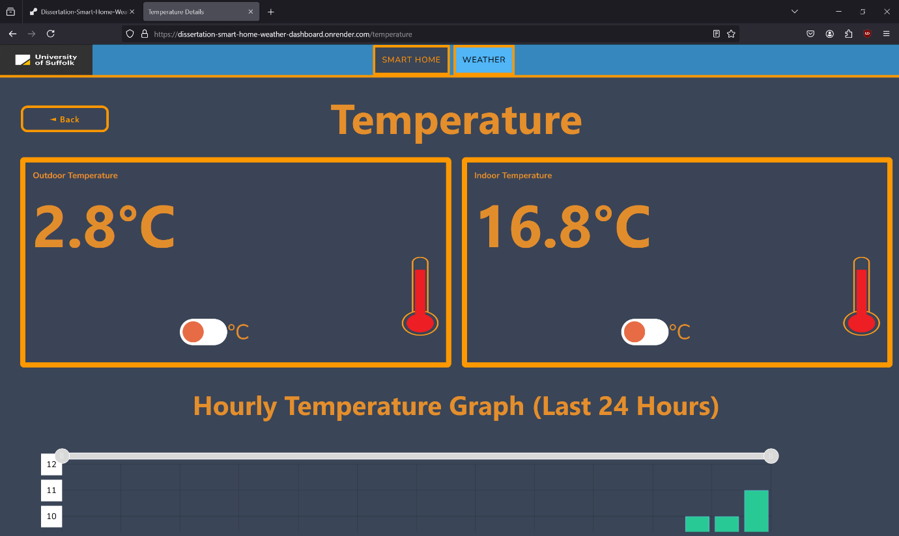

Figure - Indoor and outdoor temperature at top of temperature page.

1. Change the temperatures between Celsius and Fahrenheit using the C/F toggle switches.



Figure - Temperatures in Celsius.

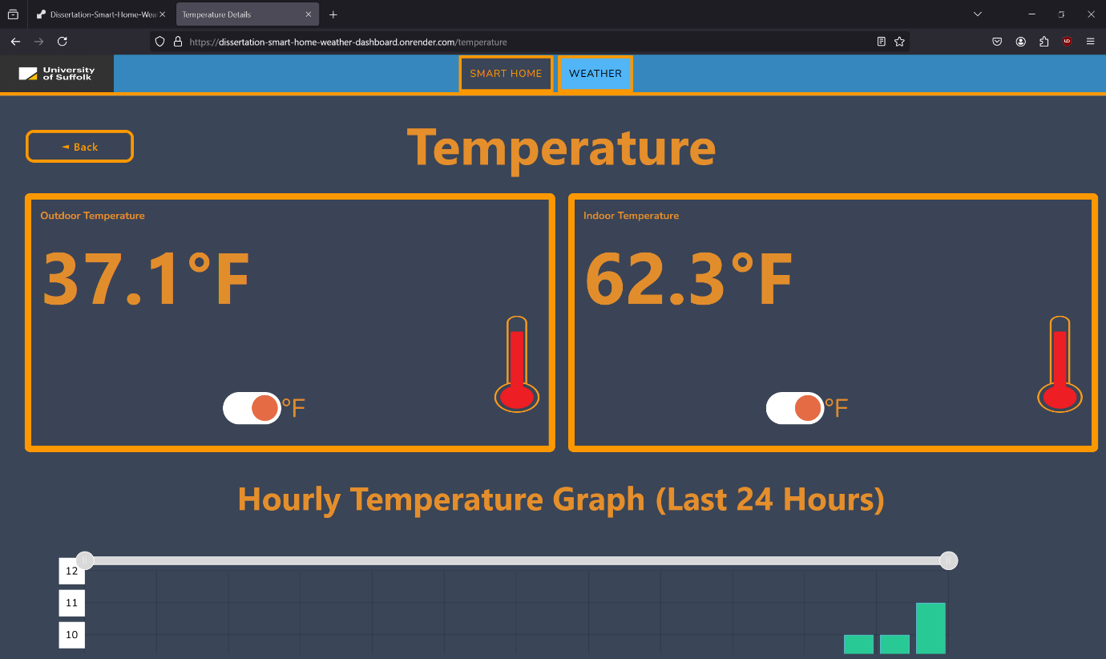

Figure - Temperatures in Fahrenheit.

1. View the hourly outdoor temperature graph. The X axis is time in hours and the Y axis is temperature in Celsius.

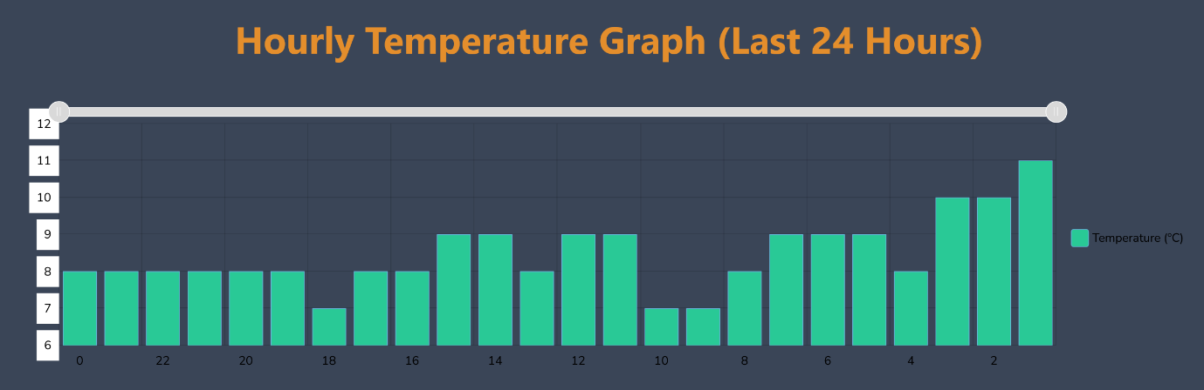

Figure - Hourly temperature graph.

1. Zoom in and out on the hourly outdoor temperature for more detailed view of a specific temperature range.



Figure - Hourly temperature graph zoomed out.

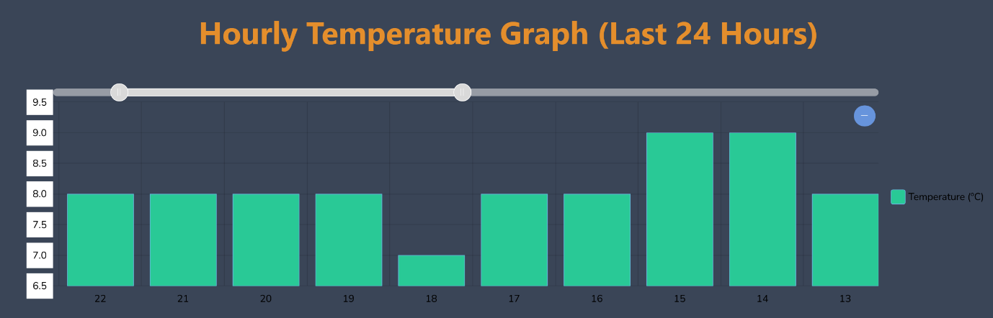

Figure - Hourly temperature graph zoomed in using slider at top of graph.

1. View the daily temperature graph for outdoor temperatures over the last 30 days. The X axis is days and the Y axis is temperature in Celsius.

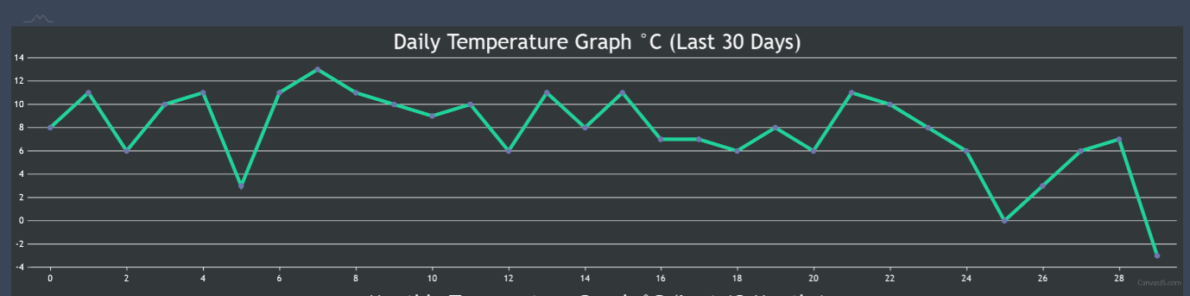

Figure - Daily temperature graph (Last 30 Days).

1. View the monthly temperature graph for outdoor temperatures over the last 12 months. The X axis is months and the Y axis is temperature in Celsius.

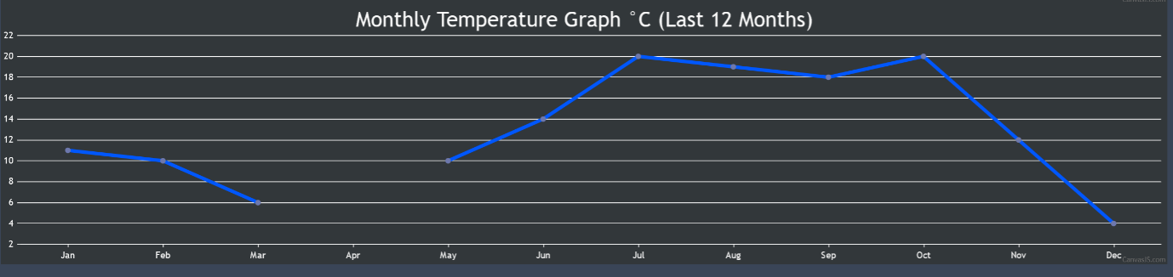

Figure - Monthly temperature graph (Last 12 Months).

1. Click the back button to go back to the previous page – only on desktop devices. On mobile devices – use the browser back button or swipe backwards on the screen.

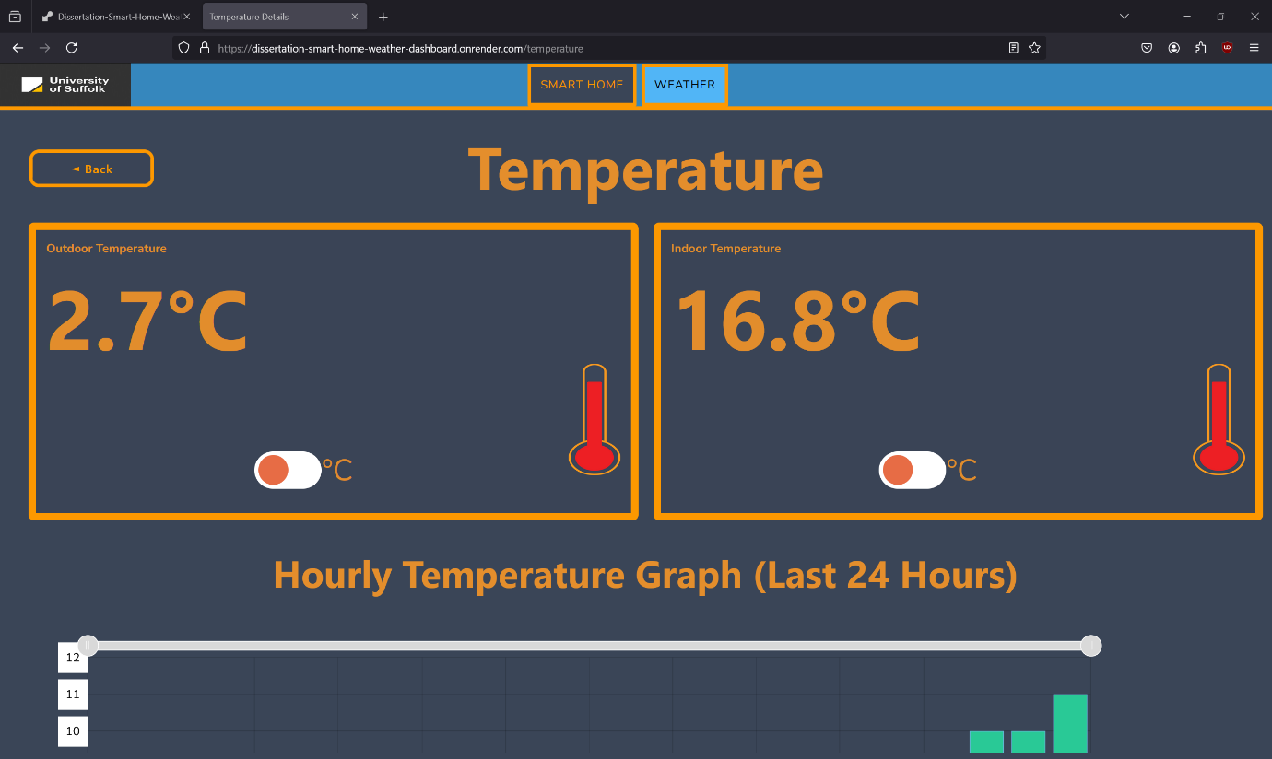

Figure - Back button.

## Viewing the Digitech Smart House Humidity

1. Click the “Details” button on the humidity tile.

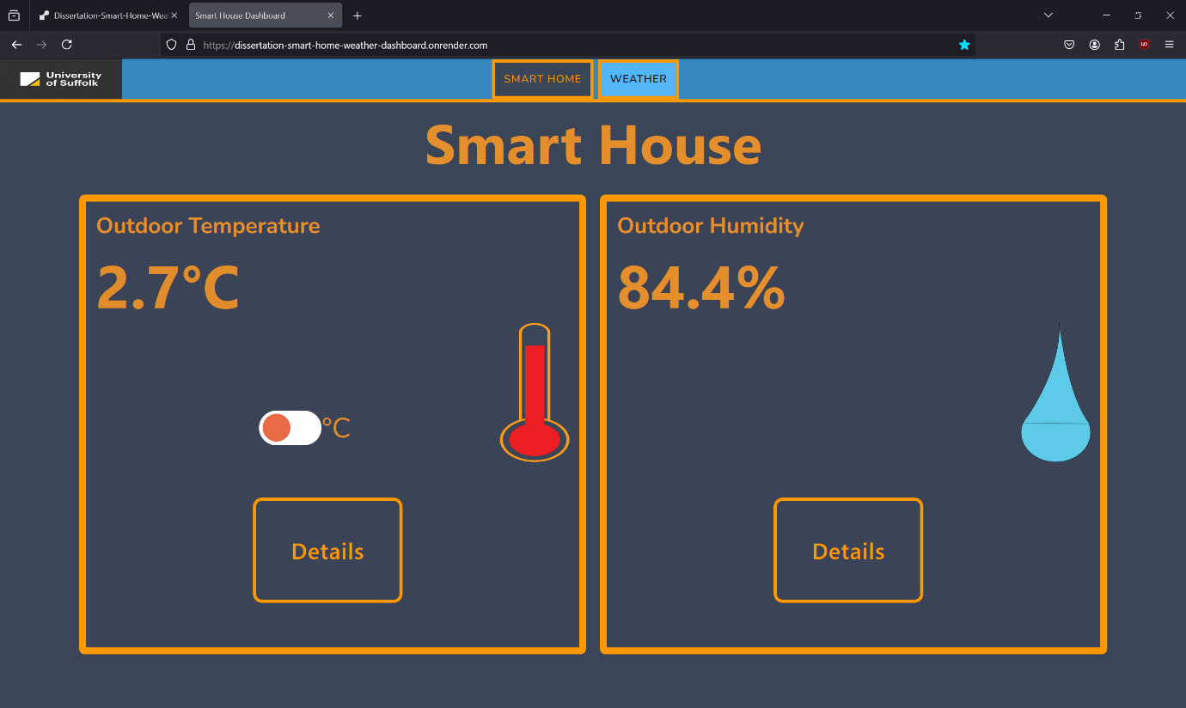

Figure - Click Details button on Outdoor Humidity tile.

1. View the indoor and outdoor smart house humidities.

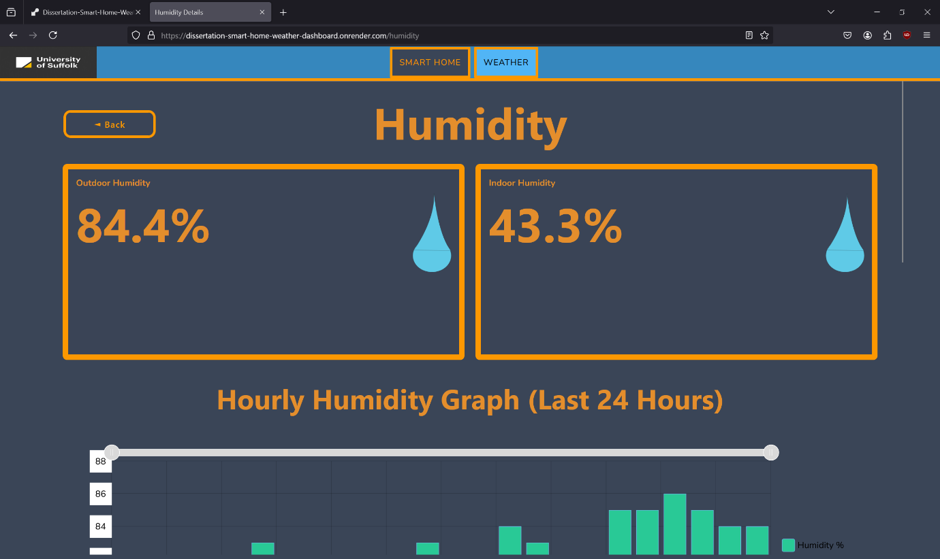

Figure - Indoor and outdoor humidity at top of Humidity page.

1. View the hourly humidity graph. The X axis is time in hours and the Y axis is humidity in percentage.

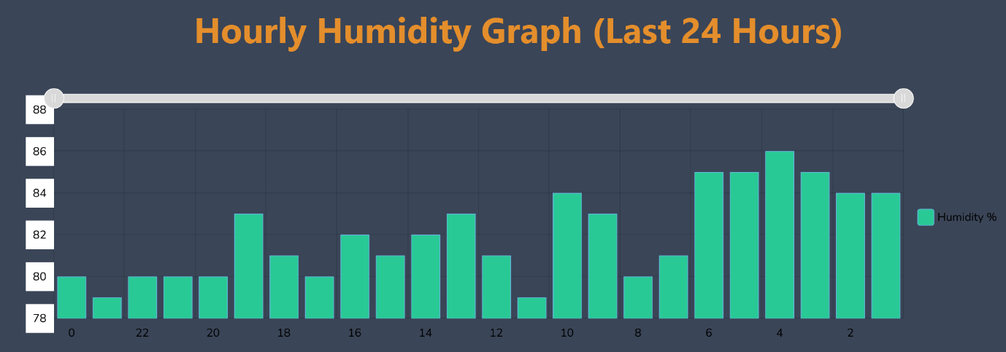

Figure - Hourly humidity graph (Last 24 Hours).

1. Zoom in and out on the hourly outdoor humidity for more detailed view of a specific temperature range.

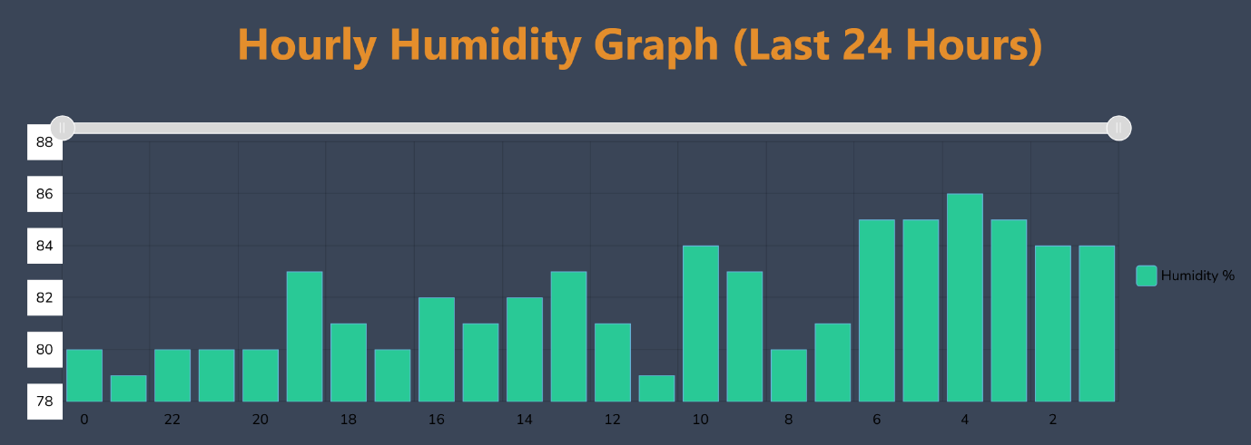

Figure - Hourly humidity graph zoomed out

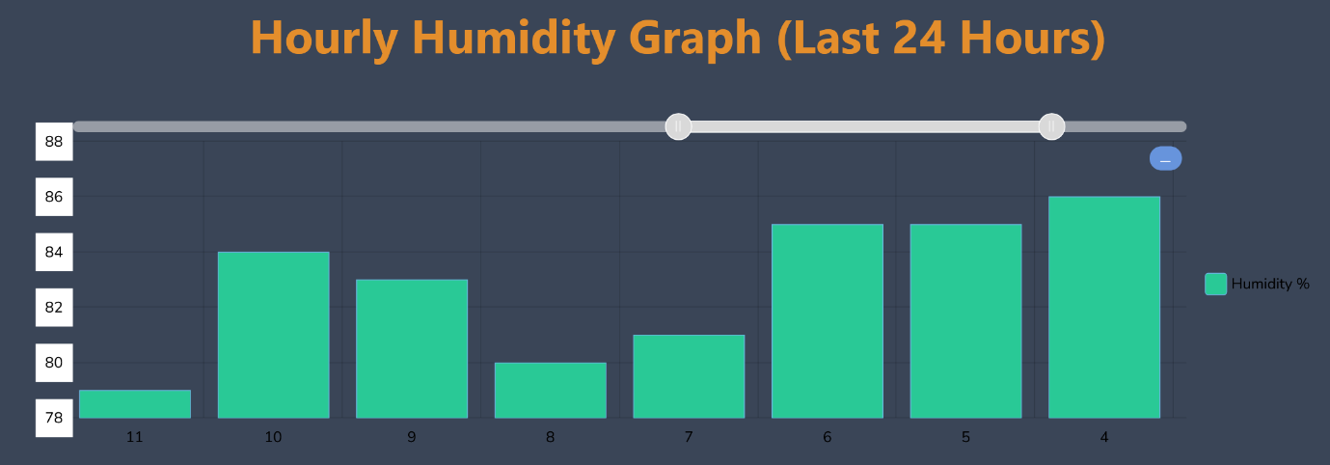

Figure - Hourly humidity graph zoomed in using slider at top of graph.

1. View the daily humidity graph for outdoor humidities over the last 30 days. The X axis is days and the Y axis is humidity in percentage.

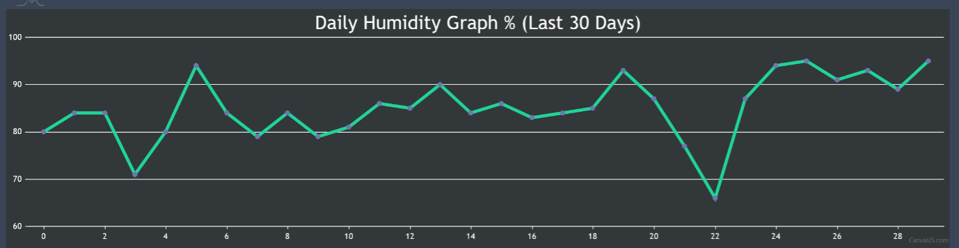

Figure - Daily humidity graph (Last 30 Days).

1. View the monthly humidity graph for outdoor humidities over the last 12 months. The X axis is months and the Y axis is humidity in percentage.

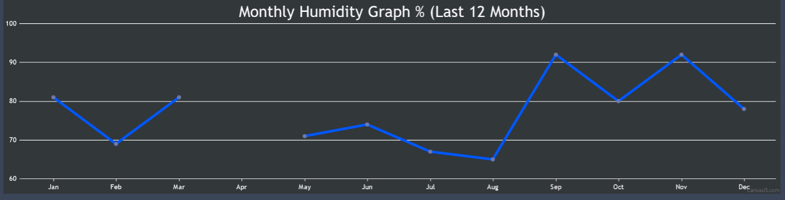

Figure - Monthly humidity graph (Last 12 Months).

1. Click the back button to go back to the previous page – only on desktop devices. On mobile devices – use the browser back button or swipe backwards on the screen.

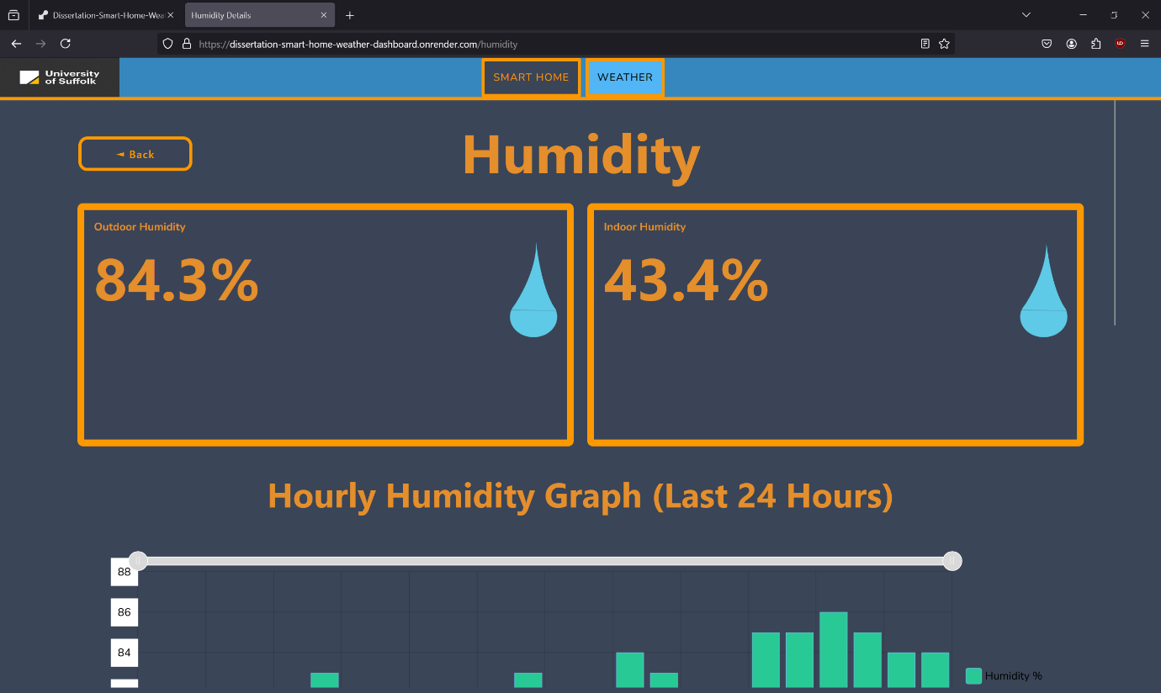

Figure - Back button.

## Viewing the Weather Dashboard

1. Click the WEATHER tab on the navbar on desktop devices.

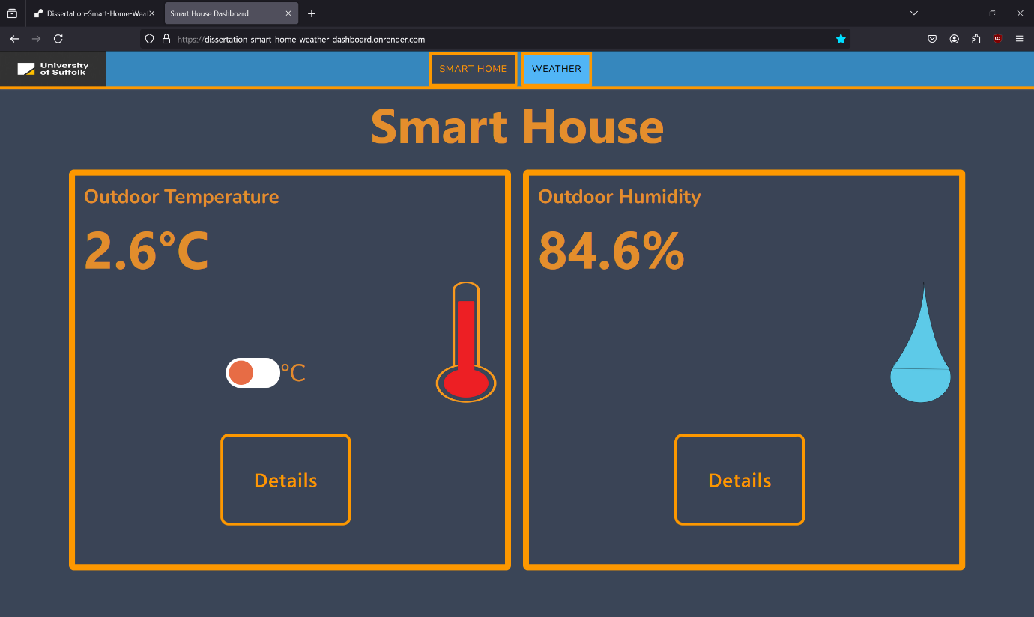

Figure - Smart House Navbar.



Figure - Closeup of navbar.

1. Click the hamburger menu (3 horizontal lines in the top right corner).

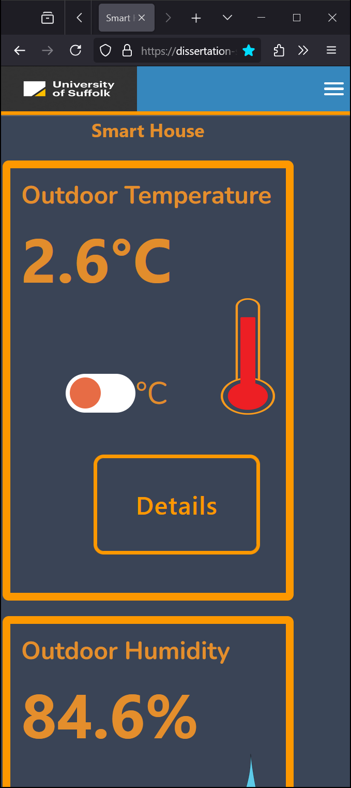

Figure - hamburger menu as seen on mobile devices.

1. Click the WEATHER button on the menu that appears.

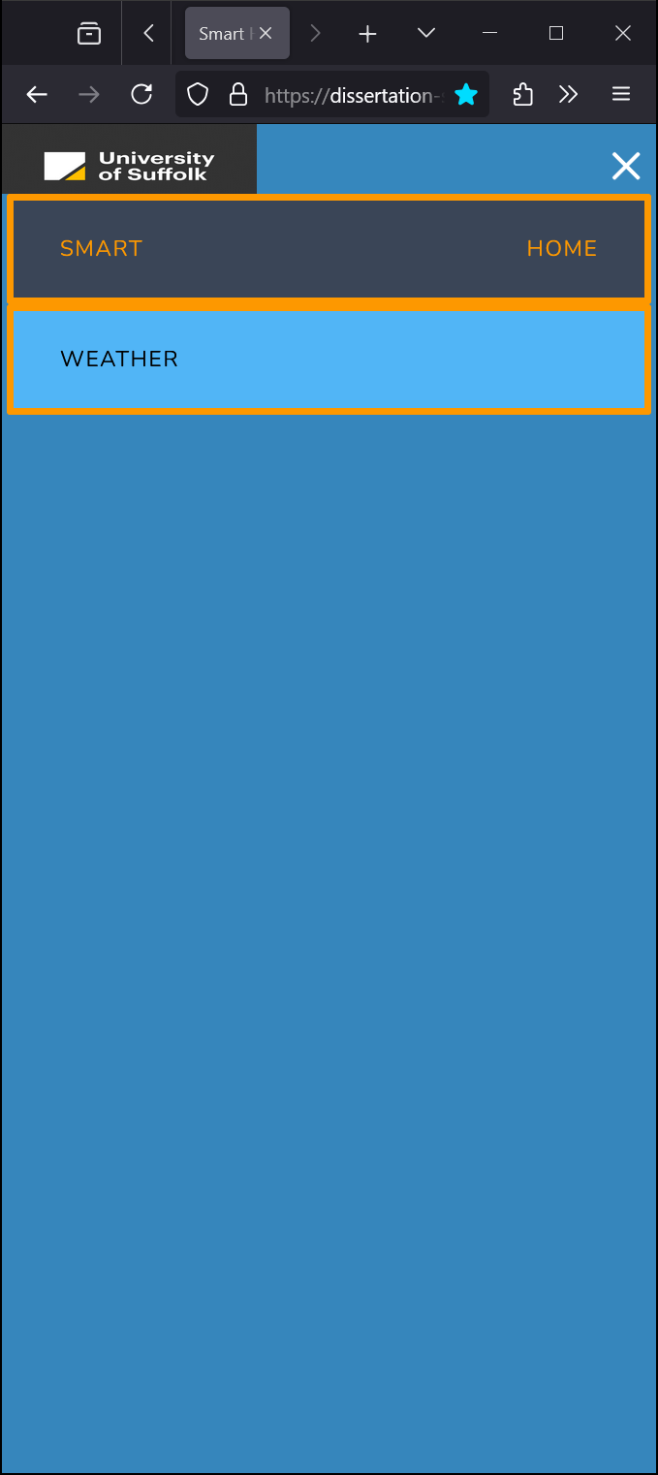

Figure - Select "Weather" on hamburger menu.

1. View the main weather dashboard – You will be able to see the following weather data:

* Actual Temperature
* Feels Like Temperature
* Weather Conditions
* UV Index
* Humidity
* Wind Speed
* Wind Direction with compass
* Air Pressure
* Air Pollution Level
* Precipitation Probability and Precipitation Type
* Pollen Count for Tree, Weed and Grass pollen.
* Visibility
* Weather map (precipitation) with link to view more detailed weather maps.

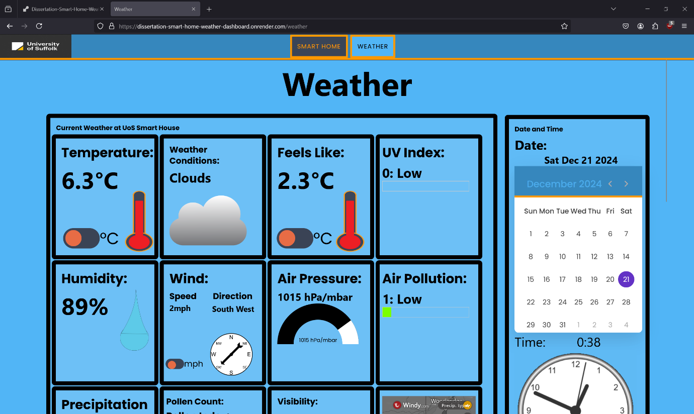

Figure - Weather Dashboard page.

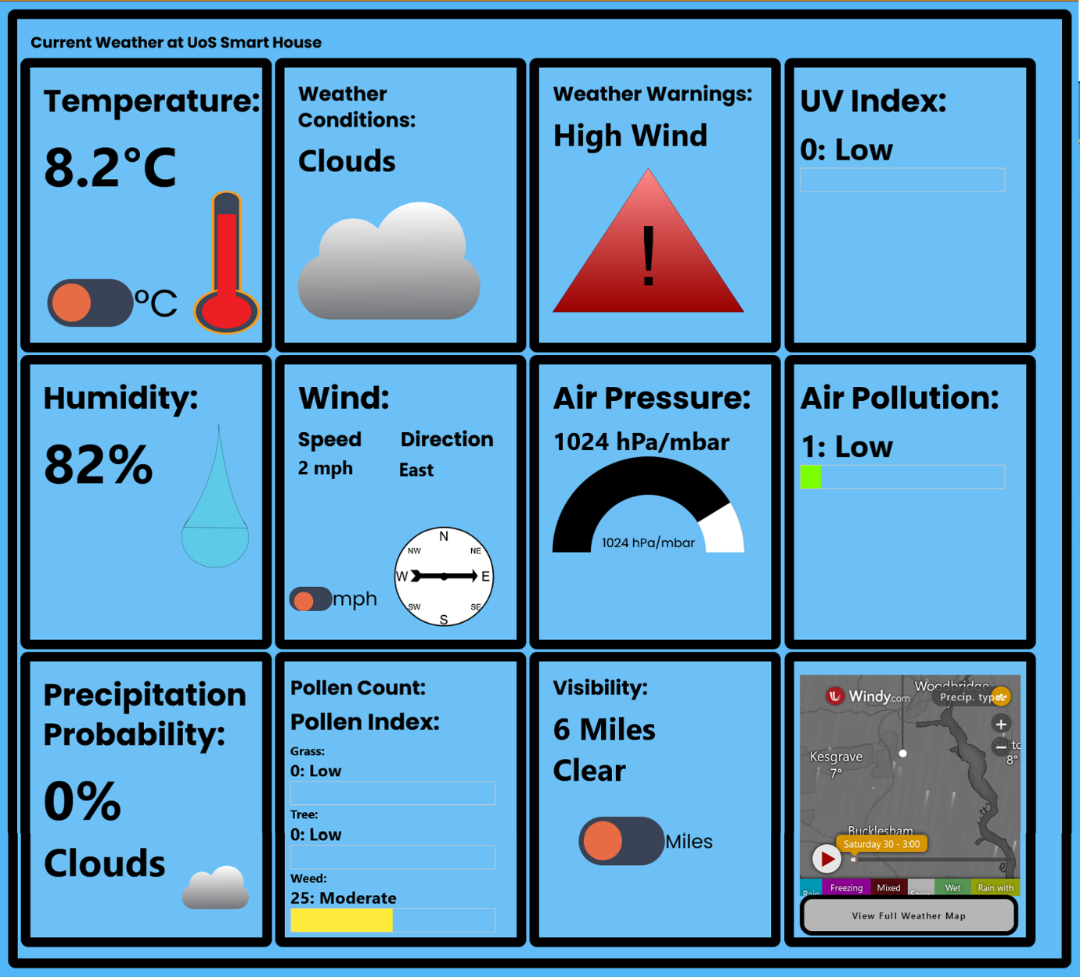

Figure - Main weather dashboard.

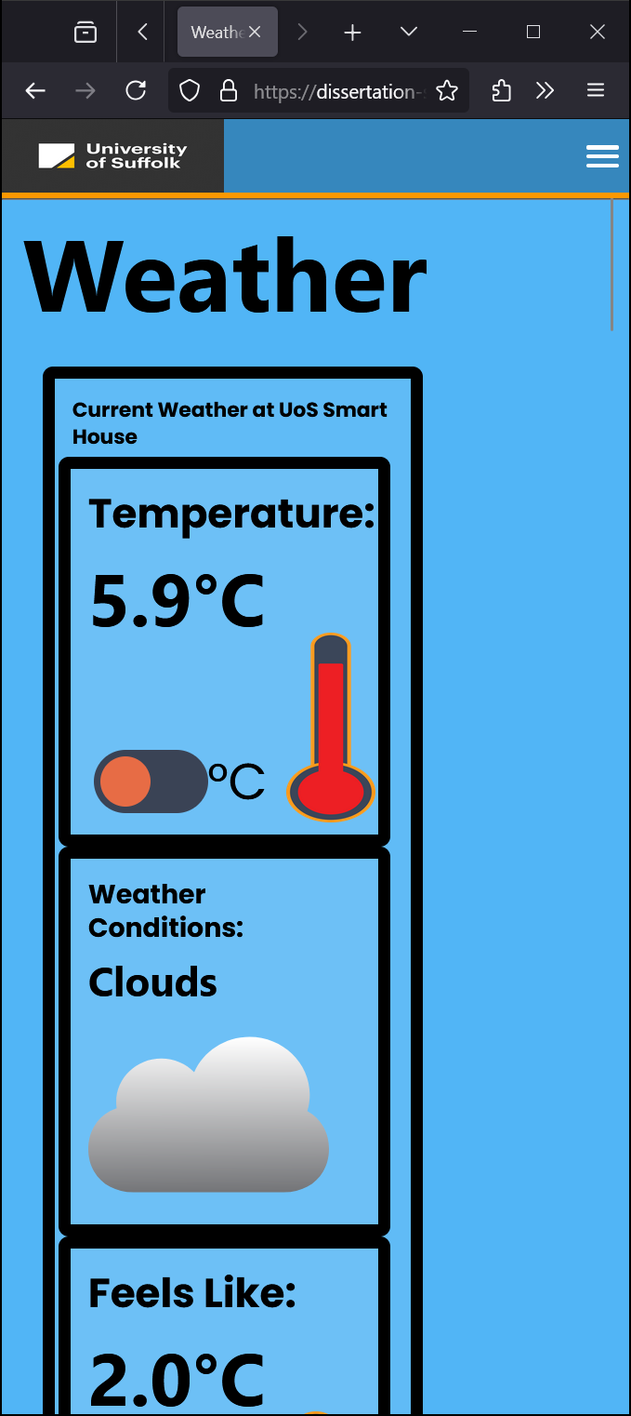

Figure - Main weather dashboard viewed on mobile device.

N.B. If the pollen API is unavailable then an error message will appear in the Pollen Count Tile instead of the Pollen Count.

1. View the date, time, clock, and calendar widget to the right of the weather dashboard. Please note that this is only available on desktop devices and will not be visible on mobile devices or where the screen size is too small or the resolution is too low.

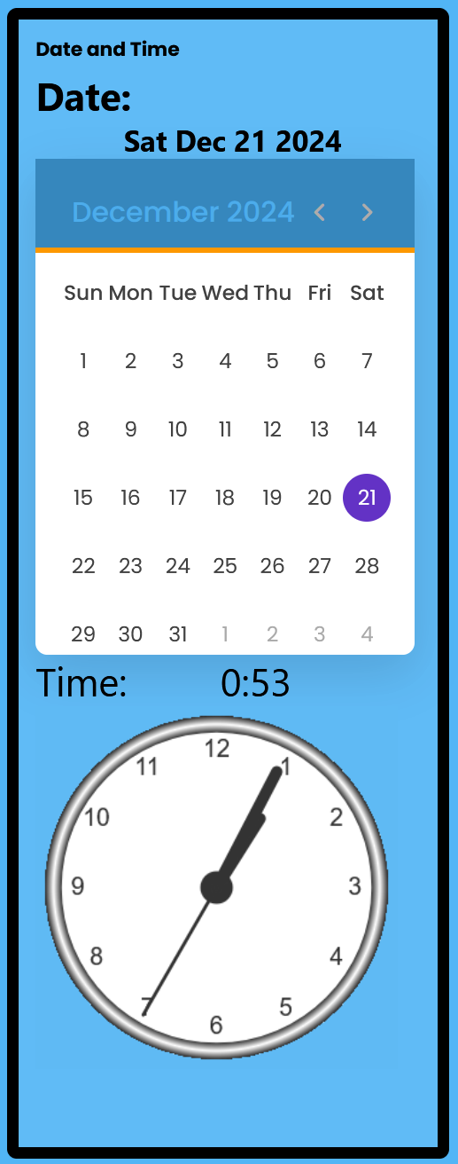

Figure - Date and Time dashboard.

1. Switch between Celsius and Fahrenheit using the C/F toggle switches for Temperature and Feels Like.

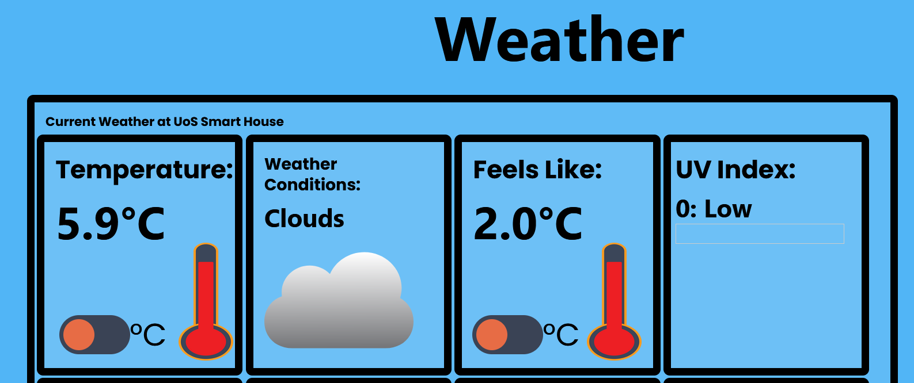

Figure - Temperature and Feels Like in Celsius.

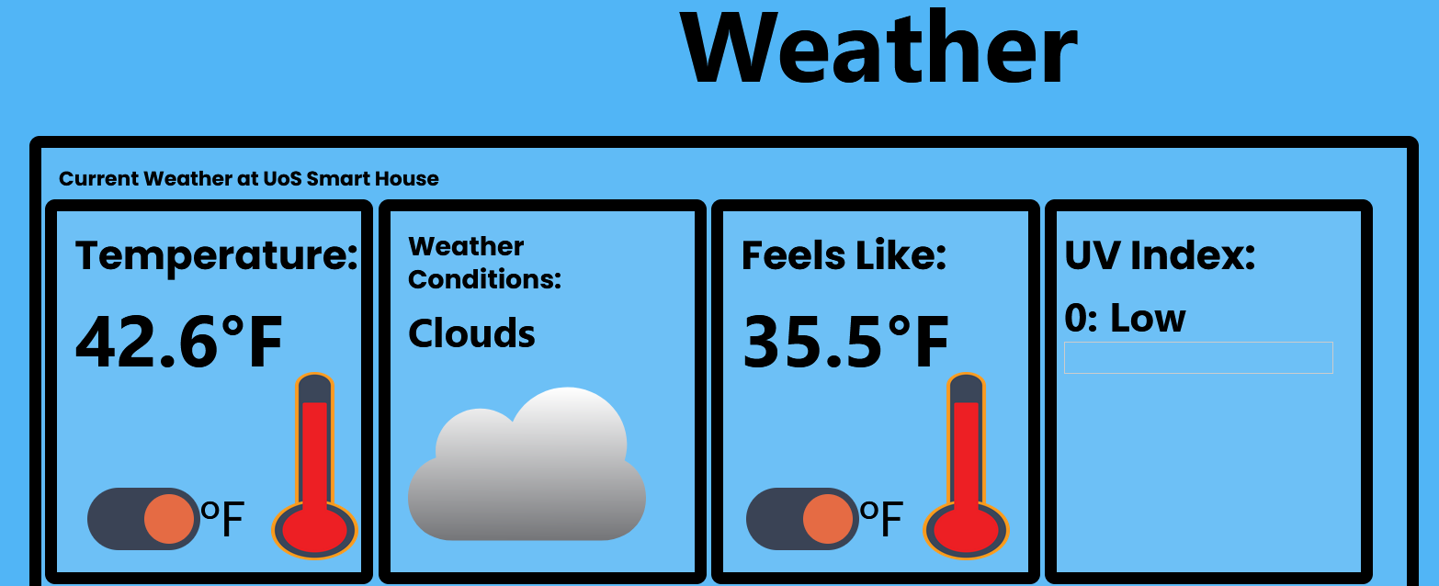

Figure - Temperature and Feels Like in Fahrenheit.

1. Switch between miles per hour and kilometres per hour using the mph/kmh toggle switches for Wind Speed.

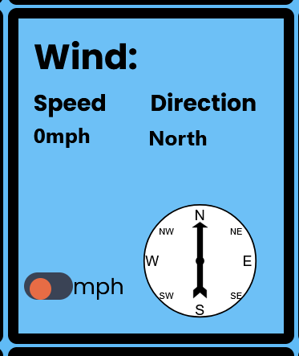

Figure - Wind speed in mph.

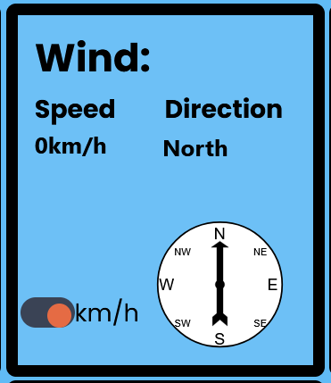

Figure - Wind speed in km/h.

1. Switch between miles and kilometres using the miles/kilometres toggle switches for Visibility

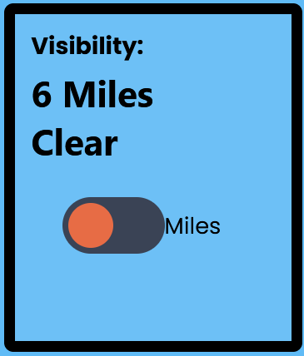

Figure - Visibility in miles.

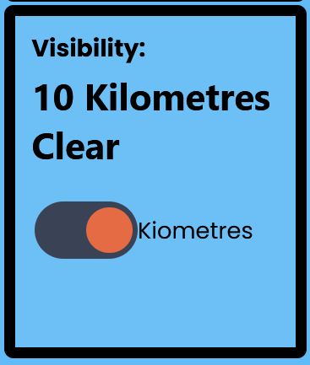

Figure - Visibility in Kilometres.

1. View the hourly weather forecast. This is scrollable on smaller sized screens and mobile devices. It displays the time in hours, temperature, and weather conditions as a relevant icon.

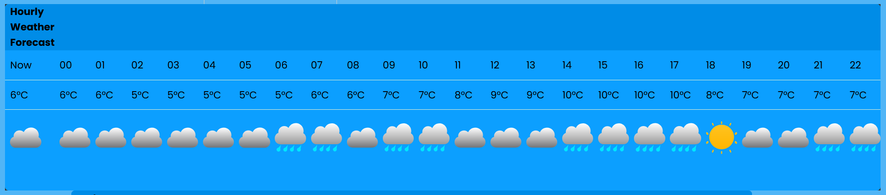

Figure - Hourly weather forecast.

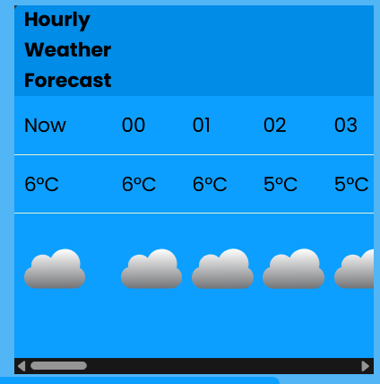

Figure - Hourly weather forecast on mobile device.

1. View the 5-day daily weather forecast. It displays the day, temperature in Celsius, weather conditions icon, precipitation chance, wind speed in mph, wind direction and humidity in percentage.

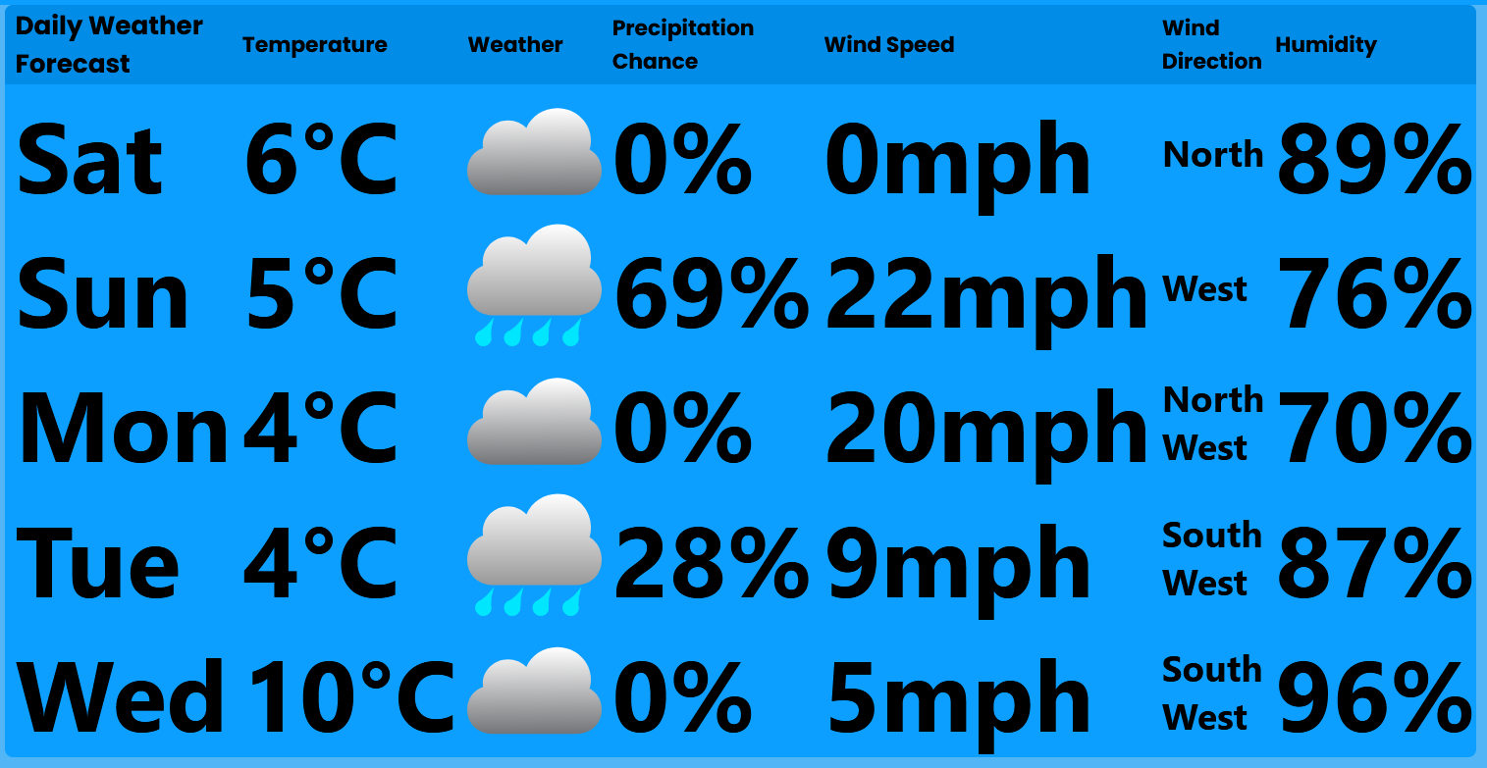

Figure - Daily weather forecast.

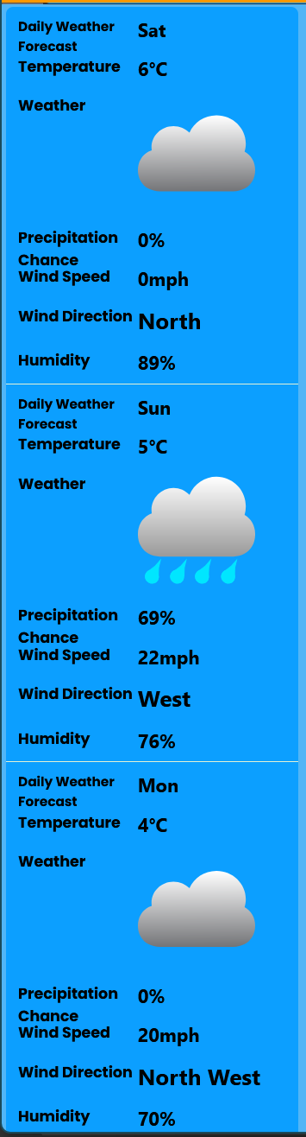

Figure - Daily weather forecast on mobile device.

## Viewing the Weather Maps

1. Click the “View Full Weather Map” button on the Weather Maps tile on the weather dashboard.



Figure - Click "View Full Weather Map" on the weather map tile.

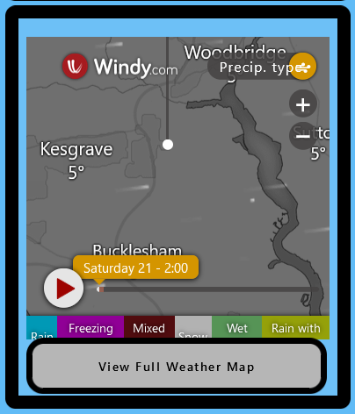

Figure - Click "View Full Weather Map" on the weather map tile.

1. The weather maps page will have loaded.

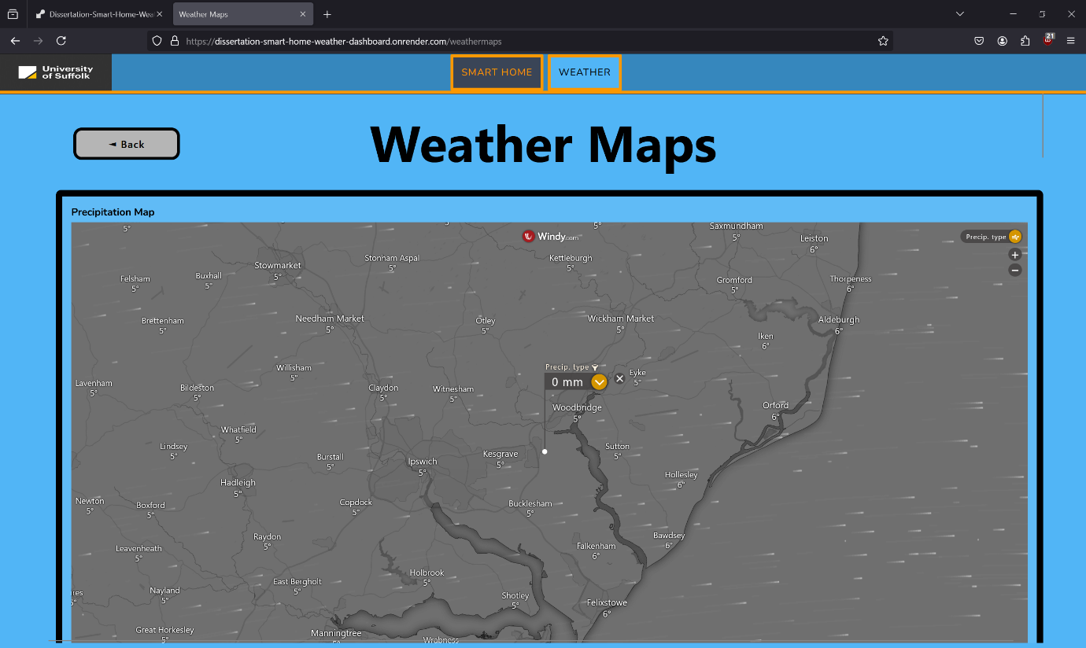

Figure - Weather Maps page.

1. View, zoom and move around the Precipitation Map. This map shows the location of precipitation and type of precipitation (rain, freezing rain, mixed ice, snow, wet snow, and rain with snow).

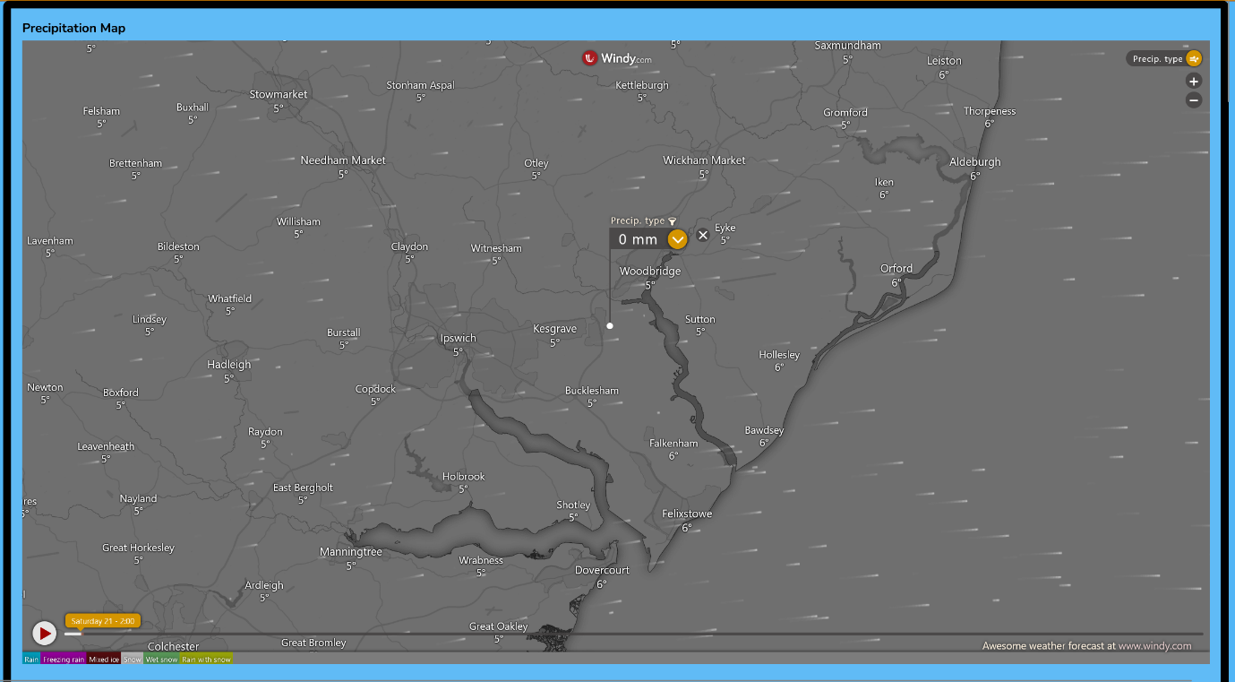

Figure - Precipitation Map.

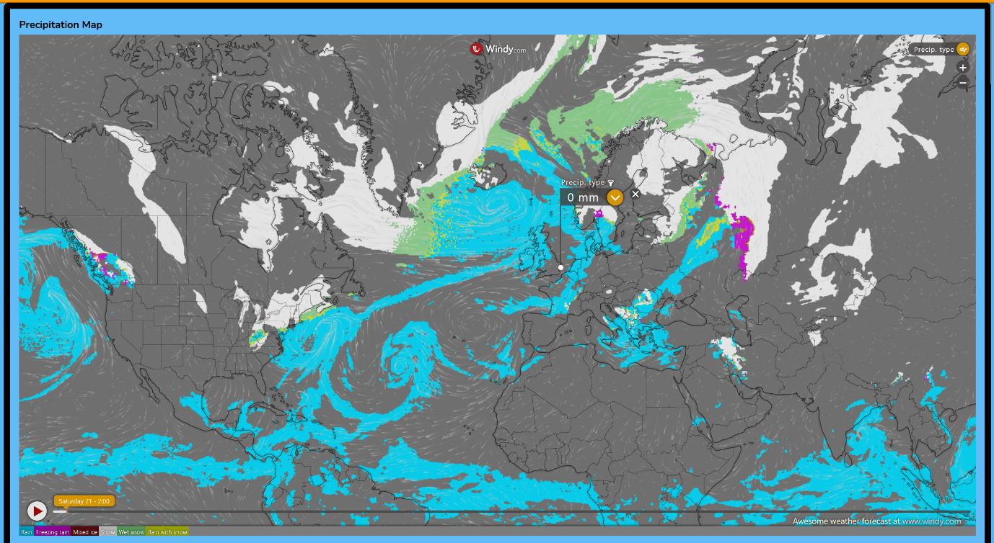

Figure - Precipitation Map zoomed out.

1. View, zoom and move around the Temperature Map. This map shows the temperature in Celsius.

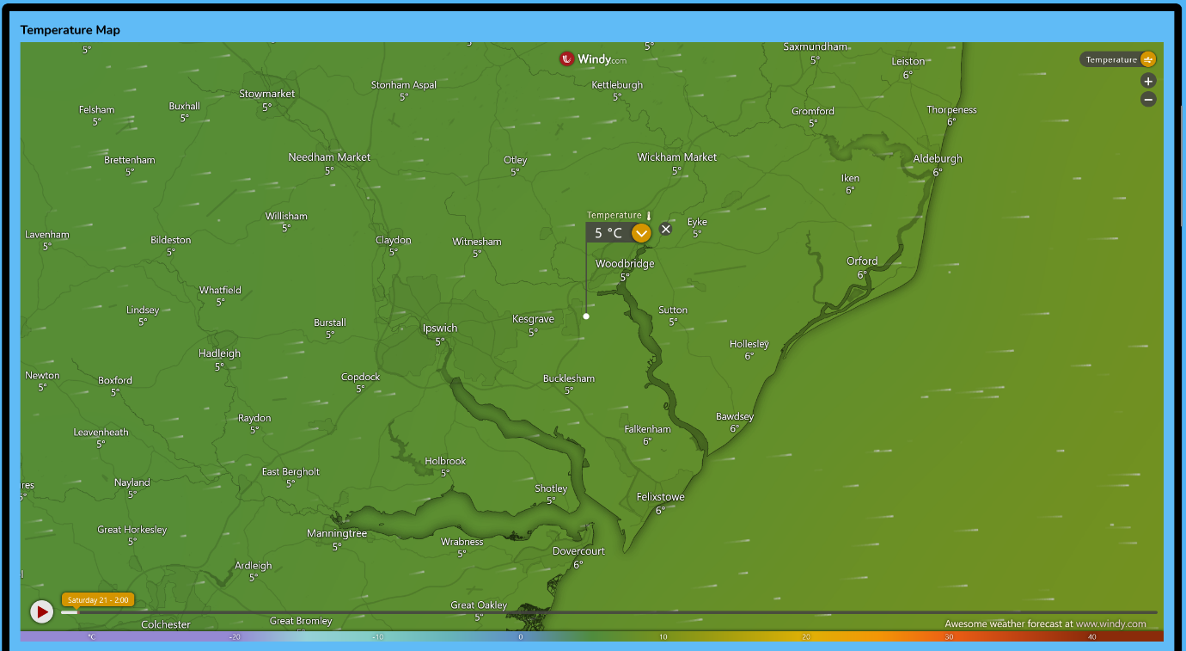

Figure - Temperature Map.

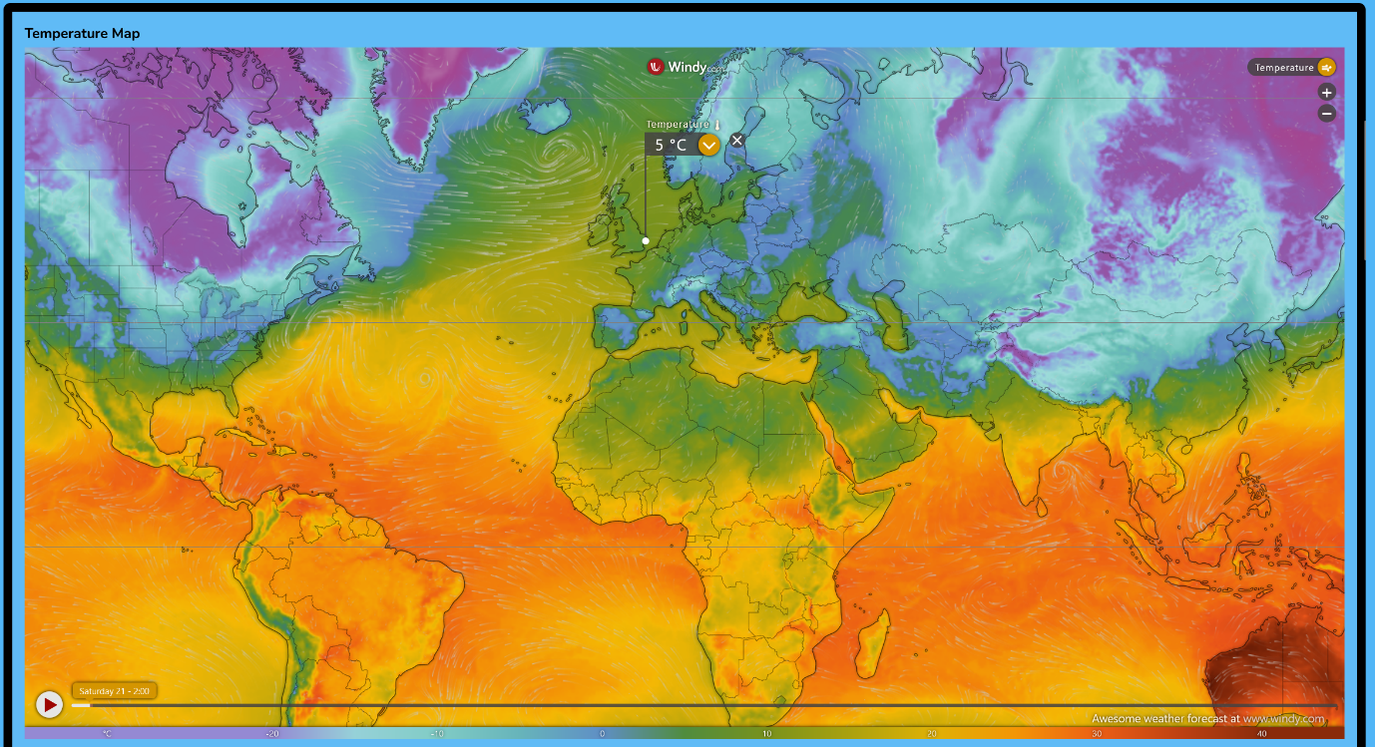

Figure - Temperature Map zoomed out.

1. View, zoom and move around the Wind Map. This map shows the wind speed in knots and the wind direction as arrows.

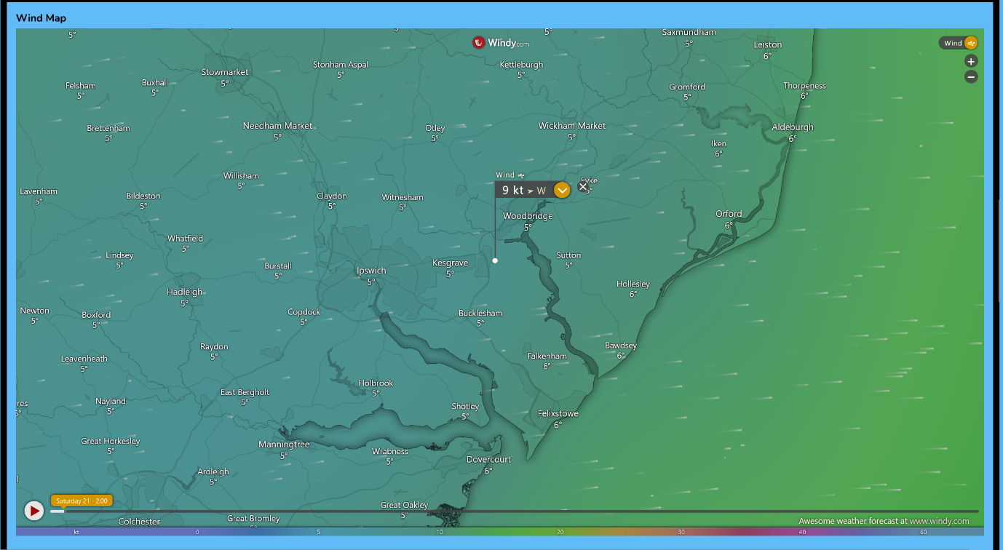

Figure - Wind Map.

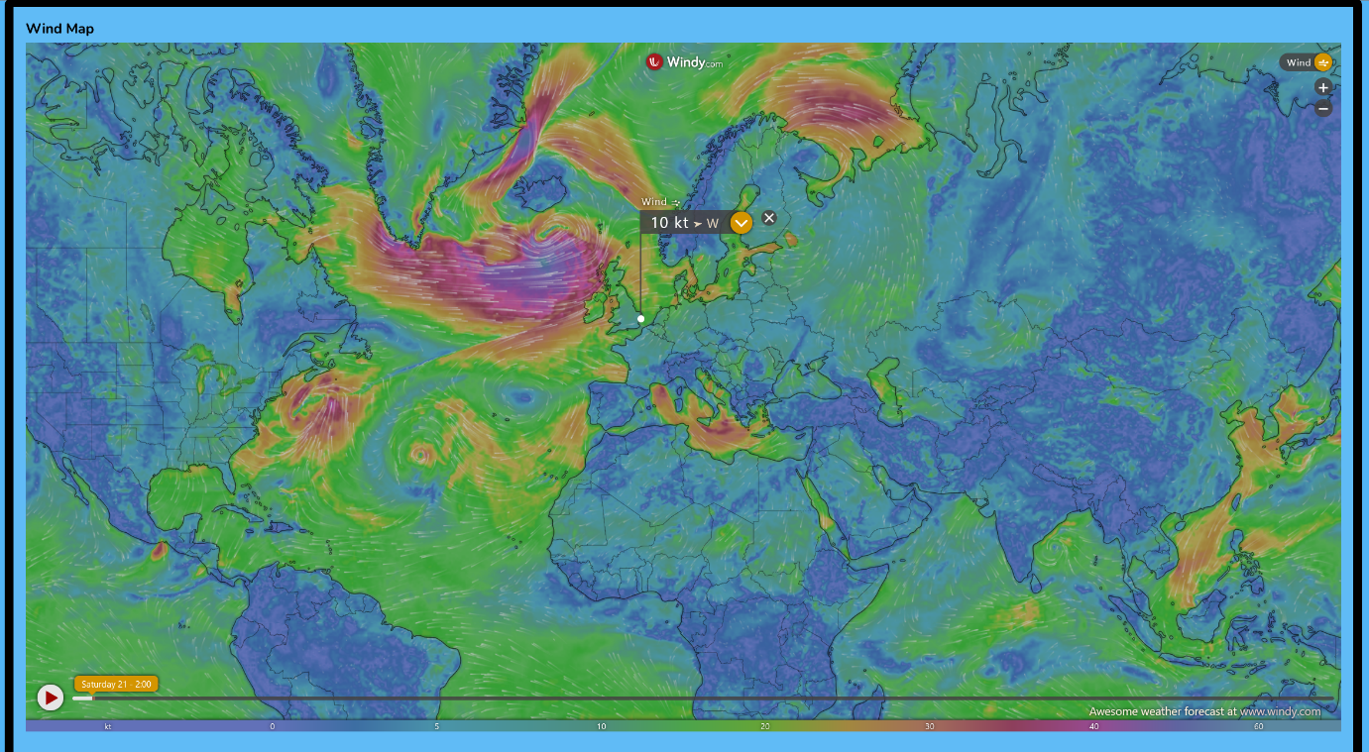

Figure - Wind Map zoomed out.

1. View, zoom and move around the Air Quality Map. This map shows the Air Quality as PM2.5 in micrograms per cubic meter.

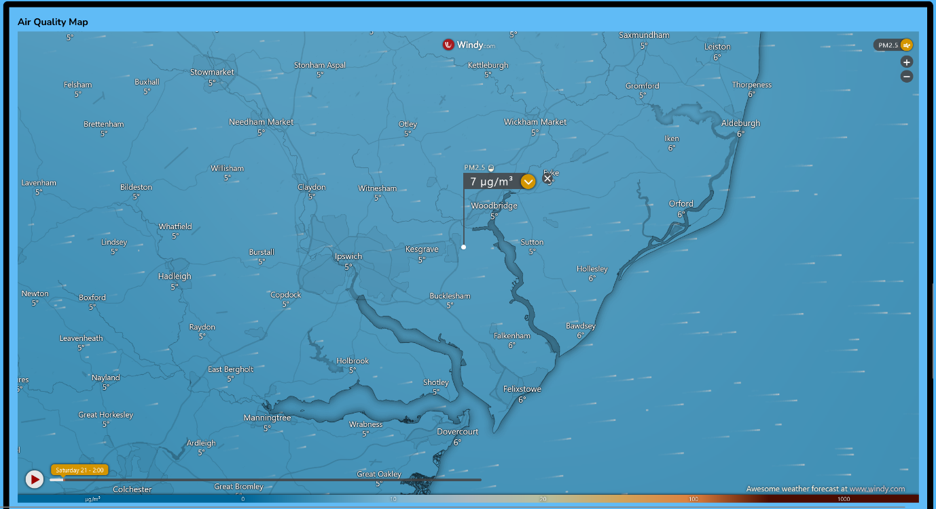

Figure - Air Quality Map.

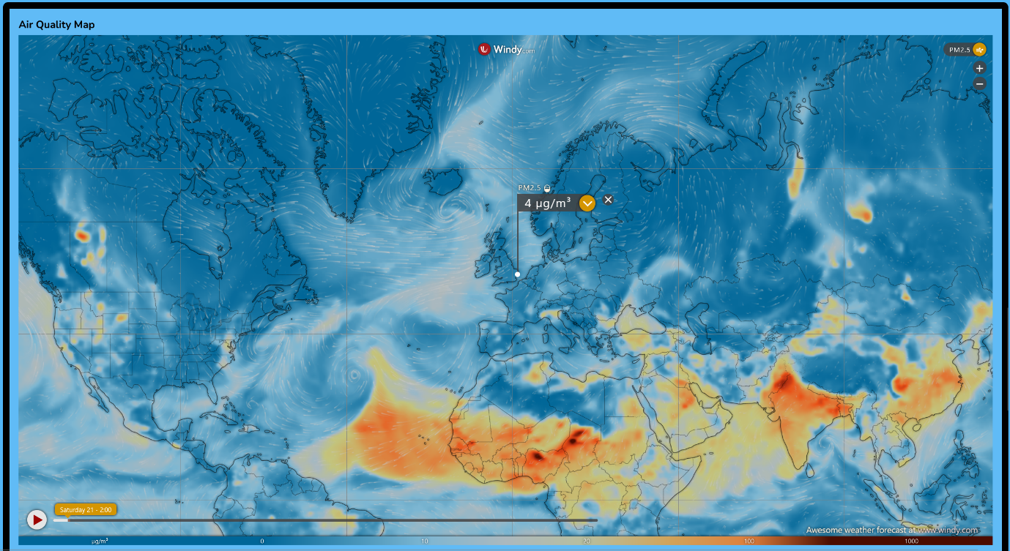

Figure - Air Quality Map zoomed out.

1. View, zoom and move around the Radar Map to locate precipitation and estimate its type.

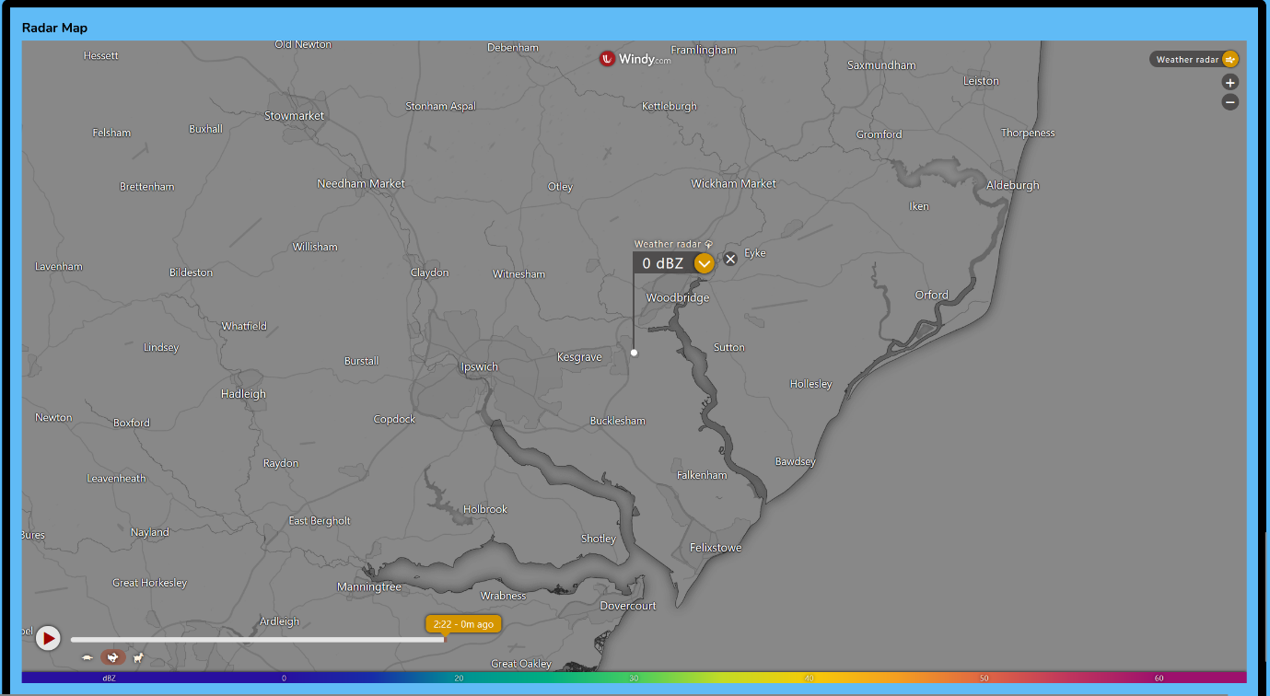

Figure - Radar Map.

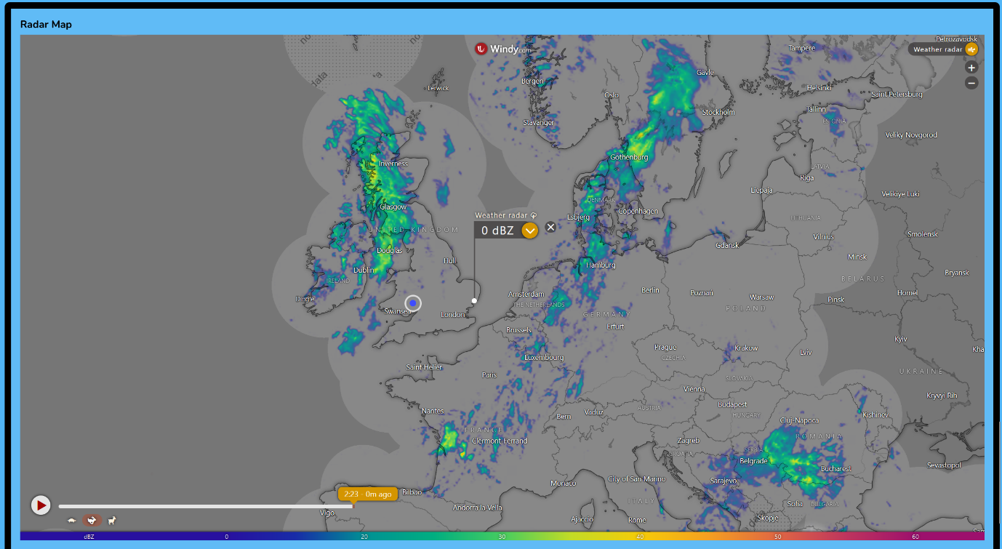

Figure - Radar Map zoomed out.

# References

Apple (2024) *Safari Support.*   
Available at: https://support.apple.com/safari  
(Accessed 21 December 2024).

Choose an open source license (2007) *GNU Affero General Public License v3.0.*   
Available at: https://choosealicense.com/licenses/agpl-3.0/  
(Accessed 21 December 2024).

Docker, Inc. (2024) *Docker Docs - Install Docker Desktop on Linux.*   
Available at: https://docs.docker.com/desktop/install/linux-install/  
(Accessed 21 December 2024).

Docker, Inc. (2024) *Docker Docs - Install Docker Desktop on Mac.*   
Available at: https://docs.docker.com/desktop/install/mac-install/  
(Accessed 21 December 2024).

Docker, Inc. (2024) *Docker Docs - Install Docker Desktop on Windows.*   
Available at: https://docs.docker.com/desktop/install/windows-install/  
(Accessed 21 December 2023).

Docker, Inc. (2024) *Docker Hub - Develop faster. Run anywhere..*   
Available at: https://hub.docker.com/  
(Accessed 21 December 2024).

Gibb, T. (2011) *How-To Geek.*   
Available at: https://www.howtogeek.com/73318/how-to-check-if-your-cpu-supports-second-level-address-translation-slat/  
(Accessed 21 December 2024).

Google (2024) *Chrome browser system requirements.*   
Available at: https://support.google.com/chrome/a/answer/7100626?hl=en  
(Accessed 21 December 2024).

Kinda Code (2022) *Docker Deskktop system requirements (Windows, macOS).*   
Available at: https://www.kindacode.com/article/docker-desktop-system-requirements-windows-macos/  
(Accessed 21 December 2024).

Microsoft (2024) *Microsoft Edge supported Operating Systems.*   
Available at: https://learn.microsoft.com/en-us/deployedge/microsoft-edge-supported-operating-systems  
(Accessed 21 December 2024).

Mozilla (2024) *Firefox System Requirements.*   
Available at: https://www.mozilla.org/en-US/firefox/133.0.3/system-requirements/  
(Accessed 21 December 2024).

Render.com (2024) *Render - Your fastest path to production.*   
Available at: https://render.com/  
(Accessed 21 December 2024).